A Real Time Research Project Report
On
SMARTRANK – A RULE BASED COLLEGE PREDICTOR

Submitted to

Jawaharlal Nehru Technological University , Hyderabad
In partial fulfillment of the requirements for the
Award of the degree of

Bachelor of Technology
in
CSE( ARTIFICIAL INTELLIGENCE AND MACHINE LEARNING)

By
ADDEPALLI JAITHRA SRIVAATSAVA (245U5A6601)
GUNDELA TEJASWINI (235U1A6644)
GUGLOTH KAVYA (235U1A6641)

Under the Guidance of
CH. JYOTHI
Assistant Professor



AVN INSTITUTE OF ENGINEERING AND TECHNOLOGY
DEPARTMENT OF CSE (AI & ML)

(Affiliated to JNTUH, Approved by A.I.C.T.E, Accredited by NAAC, New Delhi)
Koheda Road, Ramdaspally, Ibrahimpatnam
Ranga Reddy District – 501510, Telangana, India
2024 - 2025


AVN INSTITUTE OF ENGINEERING AND TECHNOLOGY
DEPARTMENT OF CSE (AI & ML)

CERTIFICATE

This is to certify that the Real Time Research Project entitled "SMARTRANK - A RULE BASED COLLEGE PREDICTOR" being submitted by ADDEPALLI JAITHRA SRIVAATSAVA, GUNDELA TEJASWINI, GUGLOTH KAVYA bearing hall ticket Nos. 245U5A6601, 235U1A6644, 235U1A6641 in partial fulfilment of the requirements for the award of Bachelor of Technology in Computer Science and Engineering [AI&ML] to the Jawaharlal Nehru Technology University, Kukatpally, Hyderabad for the academic year 2024-25 is a record of bona fide work carried out by them under our guidance and supervision.

CERTIFICATE

This is to certify that the Research Project entitled "SMARTCLASS - A SECURE ATTENDANCE SYSTEM" being submitted by GUMMADI SIDDHARTHA (235U1A6642) in partial fulfillment for the award of Bachelor of Technology in Computer Science and Engineering [AI&ML] to the Jawaharlal Nehru Technology University is a record of confined work carried out by him under my guidance and supervision.

Internal Guide Head of the Department
CH. JYOTHI Dr. M. JAYARAM
Assistant Professor Professor

CERTIFICATE

This is to certify that the Research Project entitled "SMARTCLASS - A SECURE ATTENDANCE SYSTEM" being submitted by GUMMADI SIDDHARTHA (235U1A6642) in partial fulfillment for the award of Bachelor of Technology in Computer Science and Engineering [AI&ML] to the Jawaharlal Nehru Technology University is a record of confined work carried out by him under my guidance and supervision.
CERTIFICATE

This is to certify that the Research Project entitled "SMARTCLASS - A SECURE ATTENDANCE SYSTEM" being submitted by GUMMADI SIDDHARTHA (235U1A6642) in partial fulfillment for the award of Bachelor of Technology in Computer Science and Engineering [AI&ML] to the Jawaharlal Nehru Technology University is a record of confined work carried out by him under my guidance and supervision.
CERTIFICATE

This is to certify that the Research Project entitled "SMARTCLASS - A SECURE ATTENDANCE SYSTEM" being submitted by GUMMADI SIDDHARTHA (235U1A6642) in partial fulfillment for the award of Bachelor of Technology in Computer Science and Engineering [AI&ML] to the Jawaharlal Nehru Technology University is a record of confined work carried out by him under my guidance and superv



AVN INSTITUTE OF ENGINEERING AND TECHNOLOGY
DEPARTMENT OF CSE (AI & ML)

DECLARATION
I, GUMMADI SIDDHARTHA (235U1A6642), hereby declare that the project report titled "SMARTCLASS - A SECURE ATTENDANCE SYSTEM" under the guidance of Mrs.CH.JYOTHI Assistant Professor, Department of Computer Science and Engineering [AI&ML], AVN Institute of Engineering and Technology, Ibrahimpatnam, is submitted in partial fulfillment of the requirements for the award of the degree of Bachelor of Technology in Computer Science and Engineering [AI&ML].
This is a record of bonafide work carried out by me and the results embodied in this project have not been reproduced or copied from any source. The results embodied in this thesis have not been submitted to any other University and Institute for the award of any Degree or Diploma.

We, ADDEPALLI JAITHRA SRIVAATSAVA, GUNDELA TEJASWINI, GUGLOTH KAVYA bearing hall ticket Nos. 245U5A6601, 235U1A6644, 235U1A6641 hereby declare that Real time Research project titled "SMARTRANK – A RULE BASED COLLEGE PREDICTOR" done by us under the guidance of CH.JYOTHI Assistant Professor, is submitted in partial fulfillment of the requirements for the award of the degree of Bachelor of Technology in Computer Science and Engineering [AI&ML] at AVN Institute of Engineering and Technology for Jawaharlal Nehru Technological University, Hyderabad, is our Original work.

ADDEPALLI JAITHRA SRIVAATSAVA (245U5A6601)
GUNDELA TEJASWINI (235U1A6644)
GUGLOTH KAVYA (235U1A6641)



AVN INSTITUTE OF ENGINEERING AND TECHNOLOGY
DEPARTMENT OF CSE (AI & ML)

ACKNOWLEDGEMENT

The successful completion of any task would be incomplete without mention of the people who made it possible through their guidance and encouragement, which crowns all the efforts with success.
We take this opportunity to acknowledge with thanks and a deep sense of gratitude to CH. JYOTHI, Assistant Professor, CSE (AI & ML) and project Co-ordinator, for her constant encouragement and valuable guidance during the project work.
A special vote of thanks to Dr. M. Jayaram, Professor and Head of the Department and Dr. P. Nageshwara Reddy, Principal, who have been a source of continuous motivation and support. They took time and effort to guide and correct us all through the span of this work.
We owe every much to the Department Faculty, Principal, and the Management who made our term at AVN Institute of Engineering and Technology a stepping stone for our career. We treasure every moment we had spent in the college.
Last but not the least, our heartiest gratitude to our parents and friends for their continuous encouragement and blessings. Without their support, this work would not have been possible.

ADDEPALLI JAITHRA SRIVAATSAVA (245U5A6601)
GUNDELA TEJASWINI (235U1A6644)
GUGLOTH KAVYA (235U1A6641)

ABSTRACT

Smart Rank is a web-based, rule-driven advisory system developed to assist engineering aspirants in identifying the most suitable colleges based on their entrance exam ranks and location preferences. Unlike machine learning-based predictors that often function as black boxes, Smart Rank leverages a transparent, rule-based algorithm. These rules are formulated using previous years’ cutoff data, institutional records, and user-specified filters, making the process both explainable and trustworthy for students and academic counselors alike.
The system offers an intuitive user interface that allows students to input their rank and preferences, and then generates a filtered list of colleges that align with their criteria. It enables sorting based on key parameters such as location, rank eligibility, fee structure, and course availability. Additional features such as detailed college information—including placement statistics, accreditation status, and infrastructure—enhance the decision-making process. The “Save & Compare” feature further supports students in evaluating multiple options side-by-side, ensuring informed choices.
Built using modern web technologies including Flask (Python), MySQL, HTML, CSS, and JavaScript, Smart Rank ensures performance, scalability, and maintainability. The integration of a Power BI-based dashboard provides visual insights into data trends, helping users understand national-level cutoff patterns and institutional competitiveness. Overall, the system aims to streamline the admission process, reduce uncertainty, and empower students with accessible, data-driven guidance.

Table of Contents
Chapter | Title | Subsections | Page No.
1 | Introduction | 1.1 Introduction | 1
 |  | 1.2 Motivation | 1
 |  | 1.3 Objective | 2
 |  | 1.4 Scope | 2
2 | Literature Survey | 2.1 QR Code Based Attendance System | 3
 |  | 2.2 Biometric Attendance System | 3
 |  | 2.3 RFID Based Attendance System | 3
 |  | 2.4 Summary of Existing Gaps | 3
 |  | 2.5 Our Contribution | 3
 |  | 2.6 Comparison with Existing Systems | 4
3 | System Requirements | 3.1 Software Requirements | 5
 |  | 3.2 Hardware Requirements | 5
4 | System Design Process | 4.1 Use Case Diagram | 6
 |  | 4.2 Class Diagram | 7
 |  | 4.3 Activity Diagram | 8
 |  | 4.4 Sequence Diagram | 8
 |  | 4.5 System Architecture | 9
5 | Implementation | 5.1 Module Description | 10
 |  | 5.2 Sample Codes | 10
 |  | 5.3 Frontend: HTML, CSS, JS  5.3.1 login.html  5.3.2 teacher_dashboard.html  5.3.3 mark_manual_attendance.html  5.3.4 student_dashboard.html  5.3.5 face_recognition.html | 11
 |  | 5.4 Backend (Flask – Python)  5.4.1 app.py | 39
6 | Deployment | 6.1 Deployment Environment | 43
 |  | 6.2 Deployment Steps | 43
 |  | 6.3 Challenges in Deployment | 43
 |  | 6.4 Live Application URL | 43
7 | Output Screens | Figure 7.1 – Login Page | 44
 |  | Figure 7.2 – Teacher Dashboard | 44
 |  | Figure 7.3 – Manual Attendance | 45
 |  | Figure 7.4 – Dynamic QR | 45
 |  | Figure 7.5 – Attendance Report | 45
 |  | Figure 7.6 – QR Reader | 46
 |  | Figure 7.7 – Attendance Percentage | 46
 |  | Figure 7.8 – Face Recognition | 46
8 | Testing | 8.1 Introduction to Testing and Validation | 47
 |  | 8.2 Testing and Validation Status Overview | 47
9 | Conclusion & Future Scope | 9.1 Conclusion | 48
 |  | 9.2 Future Scope | 48
10 | References |  | 50
List of Figures

Figure No. | Title | Page No.
Figure 4.1 | Use Case Diagram | 6
Figure 4.2 | Class Diagram | 7
Figure 4.3 | Activity Diagram | 8
Figure 4.4 | Sequence Diagram | 8
Figure 4.5 | System Architecture | 9
Figure 7.1 | Login Page | 44
Figure 7.2 | Teacher Dashboard | 44
Figure 7.3 | Manual Attendance | 45
Figure 7.4 | Dynamic QR | 45
Figure 7.5 | Attendance Report | 45
Figure 7.6 | QR Reader | 46
Figure 7.7 | Attendance Percentage | 46
Figure 7.8 | Face Recognition | 46

- INTRODUCTION

1.1 Problem Statement
In India, traditional attendance systems in educational institutions continue to face numerous inefficiencies and challenges. These systems often rely on manual methods such as roll-calling or paper-based registers, which are time-consuming and susceptible to human errors and fraudulent practices like proxy attendance—where one student marks attendance on behalf of another.
Although some institutions have attempted to implement digital alternatives, many still struggle with issues related to security, accuracy, and scalability. There is a noticeable gap in the availability of a secure, fully automated, and scalable solution that can reliably prevent attendance fraud and maintain accurate student records—especially in large or diverse classrooms across urban and rural India.
SmartClass aims to fill this gap by integrating dynamic QR codes and face recognition technology to automate and secure the attendance process. However, a key challenge lies in evaluating the real-world effectiveness of such a system in terms of improving accuracy, efficiency, and security within Indian educational institutions.
1.2 Objective
The primary objective of the SmartClass project is to design and develop a secure, efficient, and scalable attendance management system tailored to the needs of Indian educational institutions. Specifically, the project seeks to:
- Prevent proxy attendance using dynamic QR code scanning combined with facial recognition.
- Eliminate manual errors and ensure accurate student attendance records.
- Streamline the attendance-taking process, saving valuable time for teachers and students alike.
- Provide a scalable solution adaptable to institutions of varying sizes, including schools and colleges in rural and remote regions.
- Deliver a user-friendly interface and seamless experience for both administrators and end-users.
The overarching goal is to modernize the way attendance is managed, making it more transparent, secure, and efficient.
1.3 Scope
Geographical Scope:
SmartClass is designed for deployment in educational institutions across India, ranging from urban universities to government schools in rural areas.
Technological Scope:
The system incorporates modern technologies such as QR code generation, real-time scanning, facial recognition (OpenCV), and a web-based interface backed by a reliable Flask-Python + MySQL architecture.
Future Scope:
There is scope for integrating AI-based analytics, including student performance tracking, attendance pattern visualization through tools like Power BI, and further enhancements to optimize decision-making in educational administration.
User Scope:
The system targets teachers, students, and administrative staff, offering customized features for each user type to support their respective roles.
1.4 Motivation
The motivation behind SmartClass arises from the ongoing challenges in the Indian education system regarding attendance tracking. Manual systems are still widely used, often resulting in inaccurate data, administrative burden, and academic unfairness due to proxy attendance.
Given the vast student population in India and the increasing need for accountability in academic environments, there's a pressing demand for a transparent, secure, and automated solution.
SmartClass was conceived to meet this demand. By using advanced technologies, the project seeks to eliminate fraudulent practices, simplify attendance workflows, and promote fairness in academic records. This initiative is driven by the vision to transform attendance management into a reliable and efficient process, ultimately contributing to better governance and academic integrity in Indian educational institutions.
1.1 Problem Statement
In India, traditional attendance systems in educational institutions continue to face numerous inefficiencies and challenges. These systems often rely on manual methods such as roll-calling or paper-based registers, which are time-consuming and susceptible to human errors and fraudulent practices like proxy attendance—where one student marks attendance on behalf of another.
Although some institutions have attempted to implement digital alternatives, many still struggle with issues related to security, accuracy, and scalability. There is a noticeable gap in the availability of a secure, fully automated, and scalable solution that can reliably prevent attendance fraud and maintain accurate student records—especially in large or diverse classrooms across urban and rural India.
SmartClass aims to fill this gap by integrating dynamic QR codes and face recognition technology to automate and secure the attendance process. However, a key challenge lies in evaluating the real-world effectiveness of such a system in terms of improving accuracy, efficiency, and security within Indian educational institutions.
1.2 Objective
The primary objective of the SmartClass project is to design and develop a secure, efficient, and scalable attendance management system tailored to the needs of Indian educational institutions. Specifically, the project seeks to:
- Prevent proxy attendance using dynamic QR code scanning combined with facial recognition.
- Eliminate manual errors and ensure accurate student attendance records.
- Streamline the attendance-taking process, saving valuable time for teachers and students alike.
- Provide a scalable solution adaptable to institutions of varying sizes, including schools and colleges in rural and remote regions.
- Deliver a user-friendly interface and seamless experience for both administrators and end-users.
The overarching goal is to modernize the way attendance is managed, making it more transparent, secure, and efficient.
1.3 Scope
Geographical Scope:
SmartClass is designed for deployment in educational institutions across India, ranging from urban universities to government schools in rural areas.
Technological Scope:
The system incorporates modern technologies such as QR code generation, real-time scanning, facial recognition (OpenCV), and a web-based interface backed by a reliable Flask-Python + MySQL architecture.
Future Scope:
There is scope for integrating AI-based analytics, including student performance tracking, attendance pattern visualization through tools like Power BI, and further enhancements to optimize decision-making in educational administration.
User Scope:
The system targets teachers, students, and administrative staff, offering customized features for each user type to support their respective roles.
1.4 Motivation
The motivation behind SmartClass arises from the ongoing challenges in the Indian education system regarding attendance tracking. Manual systems are still widely used, often resulting in inaccurate data, administrative burden, and academic unfairness due to proxy attendance.
Given the vast student population in India and the increasing need for accountability in academic environments, there's a pressing demand for a transparent, secure, and automated solution.
SmartClass was conceived to meet this demand. By using advanced technologies, the project seeks to eliminate fraudulent practices, simplify attendance workflows, and promote fairness in academic records. This initiative is driven by the vision to transform attendance management into a reliable and efficient process, ultimately contributing to better governance and academic integrity in Indian educational institutions.
1.1 Problem Statement
In India, traditional attendance systems in educational institutions continue to face numerous inefficiencies and challenges. These systems often rely on manual methods such as roll-calling or paper-based registers, which are time-consuming and susceptible to human errors and fraudulent practices like proxy attendance—where one student marks attendance on behalf of another.
Although some institutions have attempted to implement digital alternatives, many still struggle with issues related to security, accuracy, and scalability. There is a noticeable gap in the availability of a secure, fully automated, and scalable solution that can reliably prevent attendance fraud and maintain accurate student records—especially in large or diverse classrooms across urban and rural India.
SmartClass aims to fill this gap by integrating dynamic QR codes and face recognition technology to automate and secure the attendance process. However, a key challenge lies in evaluating the real-world effectiveness of such a system in terms of improving accuracy, efficiency, and security within Indian educational institutions.
1.2 Objective
The primary objective of the SmartClass project is to design and develop a secure, efficient, and scalable attendance management system tailored to the needs of Indian educational institutions. Specifically, the project seeks to:
- Prevent proxy attendance using dynamic QR code scanning combined with facial recognition.
- Eliminate manual errors and ensure accurate student attendance records.
- Streamline the attendance-taking process, saving valuable time for teachers and students alike.
- Provide a scalable solution adaptable to institutions of varying sizes, including schools and colleges in rural and remote regions.
- Deliver a user-friendly interface and seamless experience for both administrators and end-users.
The overarching goal is to modernize the way attendance is managed, making it more transparent, secure, and efficient.
1.3 Scope
Geographical Scope:
SmartClass is designed for deployment in educational institutions across India, ranging from urban universities to government schools in rural areas.
Technological Scope:
The system incorporates modern technologies such as QR code generation, real-time scanning, facial recognition (OpenCV), and a web-based interface backed by a reliable Flask-Python + MySQL architecture.
Future Scope:
There is scope for integrating AI-based analytics, including student performance tracking, attendance pattern visualization through tools like Power BI, and further enhancements to optimize decision-making in educational administration.
User Scope:
The system targets teachers, students, and administrative staff, offering customized features for each user type to support their respective roles.
1.4 Motivation
The motivation behind SmartClass arises from the ongoing challenges in the Indian education system regarding attendance tracking. Manual systems are still widely used, often resulting in inaccurate data, administrative burden, and academic unfairness due to proxy attendance.
Given the vast student population in India and the increasing need for accountability in academic environments, there's a pressing demand for a transparent, secure, and automated solution.
SmartClass was conceived to meet this demand. By using advanced technologies, the project seeks to eliminate fraudulent practices, simplify attendance workflows, and promote fairness in academic records. This initiative is driven by the vision to transform attendance management into a reliable and efficient process, ultimately contributing to better governance and academic integrity in Indian educational institutions.
1.1 Problem Statement
In India, traditional attendance systems in educational institutions continue to face numerous inefficiencies and challenges. These systems often rely on manual methods such as roll-calling or paper-based registers, which are time-consuming and susceptible to human errors and fraudulent practices like proxy attendance—where one student marks attendance on behalf of another.
Although some institutions have attempted to implement digital alternatives, many still struggle with issues related to security, accuracy, and scalability. There is a noticeable gap in the availability of a secure, fully automated, and scalable solution that can reliably prevent attendance fraud and maintain accurate student records—especially in large or diverse classrooms across urban and rural India.
SmartClass aims to fill this gap by integrating dynamic QR codes and face recognition technology to automate and secure the attendance process. However, a key challenge lies in evaluating the real-world effectiveness of such a system in terms of improving accuracy, efficiency, and security within Indian educational institutions.
1.2 Objective
The primary objective of the SmartClass project is to design and develop a secure, efficient, and scalable attendance management system tailored to the needs of Indian educational institutions. Specifically, the project seeks to:
- Prevent proxy attendance using dynamic QR code scanning combined with facial recognition.
- Eliminate manual errors and ensure accurate student attendance records.
- Streamline the attendance-taking process, saving valuable time for teachers and students alike.
- Provide a scalable solution adaptable to institutions of varying sizes, including schools and colleges in rural and remote regions.
- Deliver a user-friendly interface and seamless experience for both administrators and end-users.
The overarching goal is to modernize the way attendance is managed, making it more transparent, secure, and efficient.
1.3 Scope
Geographical Scope:
SmartClass is designed for deployment in educational institutions across India, ranging from urban universities to government schools in rural areas.
Technological Scope:
The system incorporates modern technologies such as QR code generation, real-time scanning, facial recognition (OpenCV), and a web-based interface backed by a reliable Flask-Python + MySQL architecture.
Future Scope:
There is scope for integrating AI-based analytics, including student performance tracking, attendance pattern visualization through tools like Power BI, and further enhancements to optimize decision-making in educational administration.
User Scope:
The system targets teachers, students, and administrative staff, offering customized features for each user type to support their respective roles.
1.4 Motivation
The motivation behind SmartClass arises from the ongoing challenges in the Indian education system regarding attendance tracking. Manual systems are still widely used, often resulting in inaccurate data, administrative burden, and academic unfairness due to proxy attendance.
Given the vast student population in India and the increasing need for accountability in academic environments, there's a pressing demand for a transparent, secure, and automated solution.
SmartClass was conceived to meet this demand. By using advanced technologies, the project seeks to eliminate fraudulent practices, simplify attendance workflows, and promote fairness in academic records. This initiative is driven by the vision to transform attendance management into a reliable and efficient process, ultimately contributing to better governance and academic integrity in Indian educational institutions.
1.1 Intoduction
In the Indian higher education landscape, a substantial number of students annually participate in competitive entrance examinations such as JEE (Joint Entrance Examination), MHT-CET (Maharashtra Common Entrance Test), and EAMCET (Engineering, Agriculture, and Medical Common Entrance Test). Despite successfully qualifying these exams, a significant proportion of candidates remain unaware of the range of institutions available to them based on their achieved rank. The college admission process, though structured, is perceived as opaque and overwhelming, particularly for first-generation college aspirants and those from underserved communities. While several online counseling tools and predictors exist, they often impose barriers such as compulsory registration, hidden subscription models, or reliance on complex machine learning techniques that offer little to no interpretability for end-users.
This prevailing lack of accessible, trustworthy, and transparent digital platforms creates a pronounced gap in the academic advisory ecosystem. Students from rural, economically disadvantaged, or non-English-speaking backgrounds are disproportionately affected, as they are less likely to have access to private counseling services or informed academic networks. Consequently, there exists a compelling need for an open-access, rule-based advisory system that demystifies the admission decision-making process. The Smart Rank system is conceptualized to fulfill this void by leveraging historical admission data and user-defined parameters to offer a logically explainable and user-centric alternative to existing predictors.

1.2 Motivation
The conceptual foundation of Smart Rank is rooted in the observed inadequacies within the existing college counseling mechanisms available to engineering aspirants in India. Despite successfully qualifying competitive entrance examinations, a considerable number of students encounter difficulty in interpreting previous years' cutoff data, evaluating institutional credibility, and assessing their admission prospects. In the absence of structured guidance, students often resort to anecdotal evidence, peer suggestions, or unreliable internet sources, which can result in ill-informed and potentially detrimental academic decisions. Existing commercial predictors, while attempting to fill this advisory void, frequently present barriers such as restricted access, monetized features, or algorithmic opacity that undermines user trust and usability.
This situation underscores the urgent need for a transparent, inclusive, and data-informed solution that can be accessed universally without technical complexity. Smart Rank seeks to address this gap by offering a rule-based recommendation system underpinned by historical cutoff datasets and user-driven parameters such as rank, preferred location, and program of interest. The motivation behind this project is to democratize access to admission intelligence by eliminating the dependency on costly counseling services or complex AI models. By prioritizing interpretability and ease of use, the system aims to empower students—particularly those from rural or marginalized backgrounds—with autonomous decision-making tools that promote equitable access to higher education opportunities.

1.3 Objective
The primary objective of Smart Rank is to design and develop a web-based decision support system that facilitates the identification of optimal engineering colleges based on a student's entrance examination rank and stated preferences. The system is intended to accept user inputs—such as rank, preferred state or region, and course stream—and, through a rule-based evaluation mechanism, output a list of institutions that align with the candidate's eligibility. To enhance personalization, the platform incorporates dynamic filtering and sorting options based on institutional attributes including program offerings, tuition fee ranges, accreditation levels, and geographical accessibility.
In addition to generating rank-based recommendations, the system aspires to support informed and data-driven decision-making by presenting comprehensive institutional profiles. These include historical cutoff trends, placement statistics, infrastructure ratings, and accreditation credentials, thereby providing a multidimensional view of each college. Furthermore, the inclusion of interactive features such as "Save & Compare" and Power BI-driven analytics dashboards equips users with tools for in-depth comparison and visual analysis. The overarching goal is to create a functional, user-centered, and logically grounded framework that assists students in navigating the complexities of the admission process with clarity and confidence.

1.4 Scope
The scope of Smart Rank encompasses its application as a comprehensive decision-support tool for engineering aspirants across India, particularly targeting candidates appearing for prominent entrance examinations such as JEE, EAMCET, and MHT-CET. The platform has been architected with scalability and modularity in mind, allowing for seamless integration of additional entrance examinations and academic streams, such as medical sciences or management studies. Its lightweight and responsive design ensures optimal performance even on resource-constrained devices, thereby making it accessible to students in rural and underserved regions, where digital infrastructure and connectivity may be limited.
From a long-term perspective, the system offers significant potential for enhancement and diversification. Advanced features—such as AI-powered personalization engines, real-time ranking predictions based on emerging data patterns, and intelligent chatbot-based counseling—can be incorporated to elevate user experience and guidance accuracy. Furthermore, integration with government educational portals or institutional admission systems can enable real-time data synchronization and validation. Owing to its adaptable, transparent, and user-centric framework, Smart Rank holds promise as a nationally deployable academic advisory platform, capable of addressing systemic disparities in access to higher education information and decision-making support.

- LITERATURE SURVEY

Numerous digital platforms and advisory systems have been developed to assist students in selecting suitable colleges based on their entrance examination ranks. These systems aim to simplify the counseling process by providing college recommendations or access to historical cutoff data. However, many of these platforms suffer from critical limitations such as restricted access, paywalls, opaque algorithms, or a lack of interactivity. While they serve as valuable resources to an extent, the absence of transparency and personalization in most existing systems often hinders their effectiveness, particularly for students from rural or underprivileged backgrounds. A comparative review of these systems highlights their individual shortcomings and sets the foundation for the development of a more accessible and explainable solution.

2.1 JoSAA Portal
The JoSAA (Joint Seat Allocation Authority) Portal is an official government platform responsible for managing the centralized counseling and seat allocation process for admissions into IITs, NITs, IIITs, and other GFTIs. It offers accurate institutional data, including seat availability and cutoff ranks for various categories. However, JoSAA does not provide predictive functionality. Students are expected to manually analyze historical data and explore eligible colleges based on their rank, which can be time-consuming and overwhelming. The portal functions more as a seat allocation system rather than a decision-support tool, and lacks interactive, personalized guidance features.

2.2 Careers360 College Predictor
The Careers360 College Predictor is a commercially developed tool that uses machine learning and AI techniques to predict possible college options based on a student's entrance rank and category. While it employs data-driven logic and supports multiple entrance exams, its effectiveness is constrained by accessibility restrictions. Many of its features are locked behind a paywall or require mandatory user registration. Furthermore, the internal working of its predictive algorithm is not disclosed, making it difficult for students to understand or trust the recommendations. This black-box nature reduces its transparency and limits its utility for informed decision-making.

2.3 Shiksha College Finder
The Shiksha College Finder is another widely used platform that provides college predictions based on historical cutoff trends and user inputs such as rank and preferred course. Although it is relatively user-friendly, it lacks flexibility in terms of customization. The results presented are generic and do not allow for detailed filtering or prioritization based on individual preferences such as fee constraints or college facilities. Moreover, the platform does not offer insights into how the results are derived, leaving users with limited understanding of the logic behind the recommendations. This restricts its usefulness for students seeking transparent and tailored guidance.

2.4 College Pravesh
College Pravesh is a static information portal that compiles detailed data regarding entrance exam cutoffs, college rankings, and eligibility criteria. It serves as a reliable reference source, especially for browsing previous years’ cutoff data and institutional profiles. However, it does not offer an interactive or dynamic prediction system. Students must manually sift through cutoff lists and compare institutions without any automated suggestion or filtering capability. As a result, it functions more as a passive informational repository than an active decision-support system.

2.5 Our Contribution
In contrast to the limitations observed in existing tools, Smart Rank presents a novel, rule-based alternative designed to offer transparency, usability, and accessibility. It does not require user registration or subscription, thus removing entry barriers for all users, including those from rural or economically disadvantaged backgrounds. The system is built upon clearly defined, explainable logic using historical cutoff data and user-defined parameters such as rank, preferred location, course, and fee range. Smart Rank offers advanced features such as filtering, sorting, saving, and comparing colleges. Moreover, it includes a visual dashboard powered by Power BI for deeper insights. By combining simplicity with functionality, Smart Rank democratizes the college selection process, making it a more inclusive and student-friendly decision-support system.

- SYSTEM REQUIREMENTS

To ensure the effective deployment and functioning of the Smartrank System, the following hardware and software specifications are recommended. These requirements are aimed at providing a smooth user experience for both development and practical implementation.

3.1 Software requirements

Software | Purpose
Python 3.x | Programming language for backend development
Flask | Lightweight web framework for server-side logic
MySQL | Relational database for data storage
HTML, CSS, JavaScript | Frontend development and UI/UX design
Power BI | Data visualization and analytics dashboard
XAMPP / MySQL Workbench | Local database server and GUI-based admin tool
Visual Studio Code | Source code editor with development extensions
Git | Version control for collaborative development

3.2 Hardware Requirements

Hardware | Specification
Processor | Intel Core i3 or higher
RAM | Minimum 4 GB (8 GB or more recommended for better performance)
Hard Disk | 100 MB for codebase + 1 GB for MySQL data storage
Internet | Required for accessing external college information APIs

- SYSTEM DESIGN

4.1 Use Case Diagram

The Use Case Diagram for the Smart Rank system provides a high-level visualization of the interactions between the system and its primary actors—Student and Admin. It outlines the core functionalities offered to students, such as entering entrance exam rank and location, viewing predicted colleges, filtering and sorting results, saving and comparing preferred colleges, and accessing detailed college information. Meanwhile, the admin is responsible for backend operations including managing college data, updating cutoff and fee structures, and handling user accounts. All these interactions are supported by a central database, ensuring data consistency and accurate recommendations within the system.

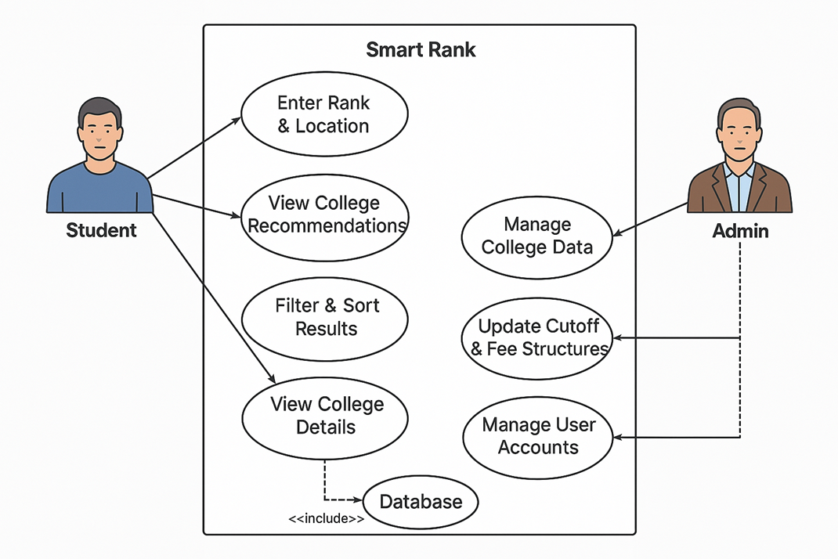

Actors:
- Student (User)
- System (Smart Rank)
Use Cases:
- Enter Rank and Preferences
- View Predicted Colleges
- Filter and Sort Colleges
- Save Colleges
- Compare College
- View detailed info
4.2 Class Diagram

The Class Diagram for the Smart Rank system represents the structural design of the application's core components and their relationships. It includes key classes such as User and its derived class Student, which contains attributes like rank, location, and preferences. The RecommendationEngine class handles logic for filtering, sorting, and processing rank data, while the DatabaseManager is responsible for fetching college records and saving user preferences. The College class encapsulates institutional data such as name, location, fee, and cutoff rank. This diagram illustrates how these classes interact, showing a clear flow of requests and data exchange among system components, which together form the foundation for generating accurate and personalized college recommendations.

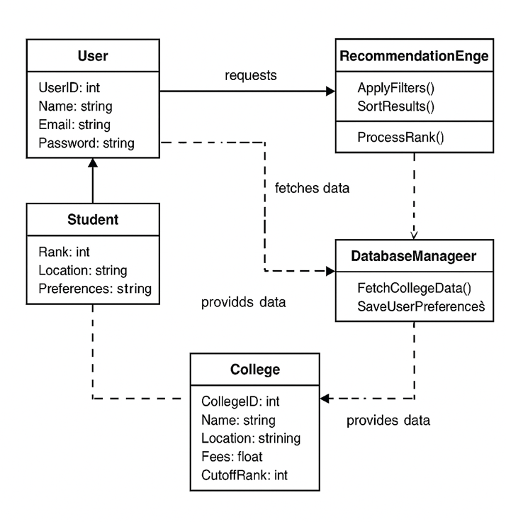
Classes:
- User
- College
- FilterEngine
- CompareModule
- DatabaseManageer

4.3 Activity Diagram

The Activity Diagram illustrates the dynamic workflow of the Smart Rank system, showcasing the sequence of actions a user follows to receive personalized college recommendations. The process begins with the user entering their entrance exam rank and preferred location, followed by input validation. Upon successful validation, the system queries the database for matching colleges and applies ranking and location-based filters to generate relevant results. The filtered college list is then displayed to the user, who may choose to save or compare colleges. If the user opts to repeat the process, the loop continues; otherwise, the system concludes the session. This diagram effectively captures the logical flow and decision-making steps involved in the user interaction with Smart Rank.
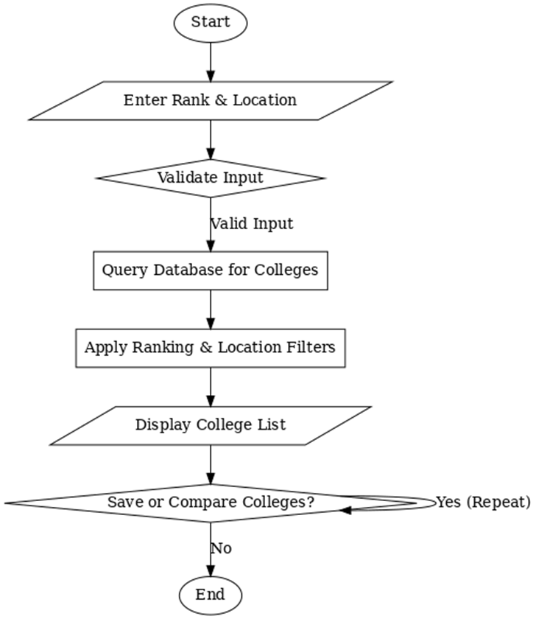

4.4 Sequence Diagram
The Sequence Diagram systematically represents the chronological interaction between key components of the Smart Rank system—namely, the user, the web-based interface, and the backend database. The process initiates when the user submits critical input parameters such as their entrance exam rank and preferred geographic location. These inputs undergo validation within the system to ensure data integrity and accuracy. Once validated, the system initiates a query to the backend database to retrieve a list of potential colleges that match the provided criteria. The retrieved data is then processed through a series of rule-based filtering mechanisms that consider factors like cutoff scores, location, and category-based reservations. The filtered results are presented to the user in a personalized and comprehensible format. Additionally, the system allows users to perform actions such as saving specific colleges for future reference or comparing multiple institutions side by side. This sequential interaction model underscores the logical flow of information and functional coordination between components, thereby ensuring a responsive and context-aware college recommendation experience.
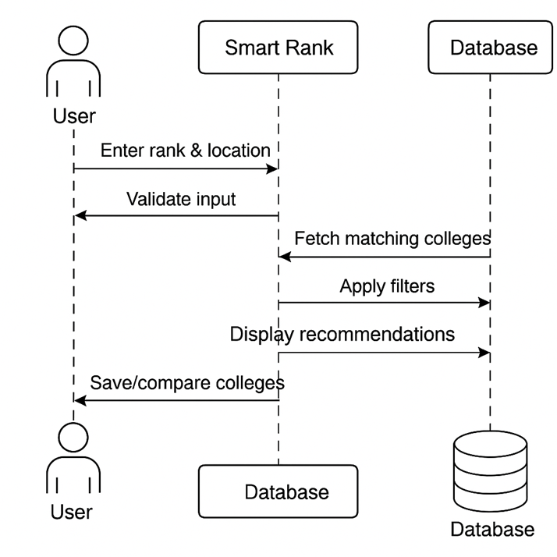

  - System Architecture
The System Architecture Diagram illustrates the layered structure of the Smart Rank application, highlighting the interaction between the frontend, backend, database, and external APIs. Users interact with the frontend, developed using HTML, CSS, and JavaScript, to input rank and location preferences. These requests are processed by the backend, built with Flask (Python), which retrieves matching data from the MySQL database. The system may also access external APIs for additional information such as maps or scholarship data. The backend then returns results to the frontend, which displays personalized college recommendations, ensuring a seamless and dynamic user experience.

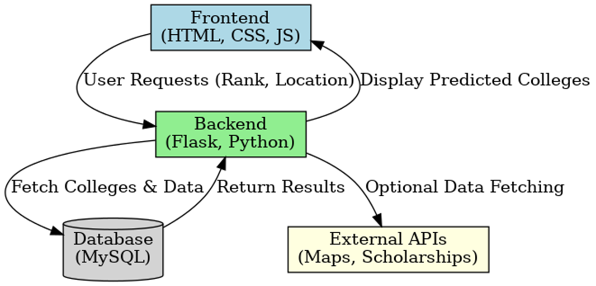
- IMPLEMENTATION

The implementation of the Smart Rank system follows a modular, multi-layered architecture using modern web development technologies. The codebase is developed in Visual Studio Code (VS Code), a versatile IDE that supports seamless development through features like debugging, Git integration, and intelligent code completion. The frontend is built using HTML, CSS, and JavaScript, ensuring a responsive and interactive user interface that allows students to input their rank and preferences. The backend is implemented using Flask, a lightweight Python web framework responsible for handling HTTP requests, validating inputs, and applying rule-based logic to filter and recommend colleges. A MySQL database manages persistent storage, housing essential data such as college profiles, cutoff ranks, fees, and user history. The database is queried dynamically to generate accurate college suggestions based on defined rules. To enable deeper insights, Power BI is integrated for visualizing key metrics such as cutoff trends, location-wise availability, and fee distributions. These dashboards assist users in understanding national admission patterns through an intuitive analytical layer. The entire system is designed to be lightweight, transparent, and scalable, ensuring accessibility even for students from rural or low-resource backgrounds.
5.1 Frontend : HTML,CSS,JS

5.1.1 index.html
<!DOCTYPE html>
<html lang="en">
<head>
<meta charset="UTF-8" />
<meta name="viewport" content="width=device-width, initial-scale=1.0" />
<title>Smart Rank - College Admission Predictor</title>
<!-- Bootstrap CSS -->
<link href="https://cdn.jsdelivr.net/npm/bootstrap@5.3.0/dist/css/bootstrap.min.css" rel="stylesheet" />
<!-- Font Awesome for icons -->
<link rel="stylesheet" href="https://cdnjs.cloudflare.com/ajax/libs/font-awesome/6.0.0/css/all.min.css" />
<!-- Google Font: Poppins -->
<link href="https://fonts.googleapis.com/css2?family=Poppins:wght@300;400;600&display=swap" rel="stylesheet" />
<style>
/* Global Styles */
body {
font-family: 'Poppins', sans-serif;
margin: 0;
padding: 0;
background: linear-gradient(135deg, #1A237E, #3949AB);
color: #fff;
}

/* Navbar Styling */
.navbar-custom {
background: rgba(0, 32, 64, 0.95);
padding: 10px 20px;
box-shadow: 0 4px 10px rgba(0, 0, 0, 0.3);
}
.navbar-custom .navbar-brand {
display: flex;
align-items: center;
}
.navbar-logo {
width: 40px;
height: 40px;
margin-right: 10px;
}
.navbar-brand-title {
margin-left: auto;
font-weight: 600;
font-size: 1.8rem;
color: #FBC02D; /* Gold accent */
}
.navbar-custom .navbar-toggler {
border: none;
color: #fff;
}
.navbar-custom .navbar-nav .nav-link {
color: #fff;
margin-left: 20px;
font-weight: 500;
transition: color 0.3s ease;
}
.navbar-custom .navbar-nav .nav-link:hover {
color: #FBC02D;
}

/* Hero Section with Random Background */
.hero-section {
position: relative;
width: 100%;
height: 350px;
background-size: cover;
background-position: center;
display: flex;
align-items: center;
justify-content: space-between;
padding: 0 50px;
transition: opacity 0.5s ease-in-out;
}
.hero-overlay {
position: absolute;
top: 0;
left: 0;
right: 0;
bottom: 0;
background: rgba(0,32,64,0.7);
z-index: 2;
}
.hero-content {
position: relative;
z-index: 3;
text-align: left;
padding: 0 50px;
}
.hero-content h1 {
font-size: 3rem;
font-weight: 600;
margin-bottom: 10px;
}
.hero-content p {
font-size: 1.2rem;
}

/* Glassmorphism Form Container */
.form-container {
max-width: 500px;
background: rgba(255, 255, 255, 0.85);
margin: -80px auto 0 auto;
padding: 40px;
border-radius: 10px;
box-shadow: 0 8px 30px rgba(0, 0, 0, 0.3);
backdrop-filter: blur(10px);
position: relative;
z-index: 4;
color: #002f5f;
}
.form-container h2 {
text-align: center;
margin-bottom: 25px;
font-weight: 600;
color: #002f5f;
}
.form-label {
font-weight: 500;
margin-bottom: 5px;
}
.input-group-text {
background-color: rgba(255, 255, 255, 0.9);
border: 1px solid #ccc;
border-radius: 5px 0 0 5px;
color: #002f5f;
}
input[type="number"],
input[type="text"],
select {
border: 1px solid #ccc;
border-left: none;
border-radius: 0 5px 5px 0;
padding: 10px;
width: 100%;
transition: border-color 0.2s ease;
color: #002f5f;
}
input:focus,
select:focus {
outline: none;
border-color: #002f5f !important;
}
.btn-primary {
background-color: #FBC02D;
border: none;
padding: 12px 0;
border-radius: 5px;
width: 100%;
font-size: 16px;
margin-top: 15px;
transition: background 0.3s ease;
color: #fff;
}
.btn-primary:hover {
background-color: #D68910;
}
.auth-links {
text-align: center;
margin-top: 15px;
}
.auth-links a {
text-decoration: none;
color: #002f5f;
margin: 0 10px;
transition: color 0.3s ease;
}
.auth-links a:hover {
color: #001b3a;
}

/* Footer Styling */
.footer {
text-align: center;
margin-top: 50px;
font-size: 0.9rem;
color: #ccc;
padding: 20px 0;
background: #0D47A1;
}
</style>
</head>
<body>
<!-- Navbar -->
<nav class="navbar navbar-expand-lg navbar-custom">
<div class="container">
<a class="navbar-brand" href="#">
<svg class="navbar-logo" viewBox="0 0 200 200" xmlns="http://www.w3.org/2000/svg">
<defs>
<linearGradient id="grad1" x1="0%" y1="0%" x2="100%" y2="0%">
<stop offset="0%" style="stop-color:#004080; stop-opacity:1" />
<stop offset="100%" style="stop-color:#0074D9; stop-opacity:1" />
</linearGradient>
</defs>
<circle cx="100" cy="100" r="90" fill="url(#grad1)" />
<text x="100" y="115" font-family="Poppins, sans-serif" font-size="50" fill="#ffffff" text-anchor="middle" font-weight="bold">SR</text>
</svg>
</a>
<button class="navbar-toggler" type="button" data-bs-toggle="collapse" data-bs-target="#navbarNav"
aria-controls="navbarNav" aria-expanded="false" aria-label="Toggle navigation">
<span class="navbar-toggler-icon"><i class="fa-solid fa-bars" style="color:#fff;"></i></span>
</button>
<div class="collapse navbar-collapse" id="navbarNav">
<ul class="navbar-nav ms-auto">
<li class="nav-item">
<a class="nav-link" href="#about">About</a>
</li>
<li class="nav-item">
<a class="nav-link" href="#support">Contact Support</a>
</li>
<li class="nav-item">
<a class="nav-link" href="tel:+1234567890">Contact No</a>
</li>
</ul>
</div>
<span class="navbar-brand-title">Smart Rank</span>
</div>
</nav>

<!-- Hero Section with Random Background -->
<div class="hero-section" id="heroSection">
<div class="hero-overlay"></div>
<div class="hero-content">
<h1>Welcome to Smart Rank</h1>
<p>Your Trusted Guide for College Admissions</p>
</div>
</div>

<!-- Glassmorphism Form Container -->
<div class="container form-container">
{% if session.username %}
<!-- Show College Search Form -->
<h2 class="text-center">Find Your College</h2>
<form action="/predict" method="POST">
<div class="mb-3">
<label for="rank" class="form-label">Your Rank:</label>
<div class="input-group">
<span class="input-group-text"><i class="fa-solid fa-trophy"></i></span>
<input type="number" class="form-control" name="rank" id="rank" required placeholder="Enter your rank">
</div>
</div>
<div class="mb-3">
<label for="category" class="form-label">Category:</label>
<div class="input-group">
<span class="input-group-text"><i class="fa-solid fa-user-tag"></i></span>
<select class="form-select" name="category" id="category" required>
<option value="General">General</option>
<option value="OBC">OBC</option>
<option value="SC">SC</option>
<option value="ST">ST</option>
<option value="BC">BC</option>
<option value="BC_D">BC_D</option>
</select>
</div>
</div>
<div class="mb-3">
<label for="location" class="form-label">Preferred Location:</label>
<div class="input-group">
<span class="input-group-text"><i class="fa-solid fa-location-dot"></i></span>
<input type="text" class="form-control" name="location" id="location" required placeholder="Enter your state/city">
</div>
</div>
<button type="submit" class="btn btn-primary">Find Colleges</button>
</form>
<div class="auth-links">
<p>Logged in as {{ session.username }} <a href="{{ url_for('logout') }}">Logout</a></p>
</div>
{% else %}
<!-- Show Login Form -->
<h2 class="text-center">Login to Smart Rank</h2>
{% with messages = get_flashed_messages(with_categories=true) %}
{% if messages %}
{% for category, message in messages %}
<div class="alert alert-{{ category }} alert-dismissible fade show" role="alert">
{{ message }}
<button type="button" class="btn-close" data-bs-dismiss="alert"></button>
</div>
{% endfor %}
{% endif %}
{% endwith %}
<form method="POST" action="/home">
<div class="mb-3">
<label for="username" class="form-label">Username:</label>
<div class="input-group">
<span class="input-group-text"><i class="fa-solid fa-user"></i></span>
<input type="text" class="form-control" name="username" id="username" required placeholder="Enter your username">
</div>
</div>
<div class="mb-3">
<label for="password" class="form-label">Password:</label>
<div class="input-group">
<span class="input-group-text"><i class="fa-solid fa-lock"></i></span>
<input type="password" class="form-control" name="password" id="password" required placeholder="Enter your password">
</div>
</div>
<button type="submit" class="btn btn-primary">Login</button>
<p class="mt-3 text-center">Don't have an account? <a href="{{ url_for('signup') }}">Sign Up</a></p>
</form>
{% endif %}
</div>

<!-- Footer -->
<footer class="footer">
<p>&copy; 2025 Smart Rank. All rights reserved.</p>
</footer>

<!-- JavaScript to Change Background Every 10 Seconds with Fade Effect -->
<script>
const bgImages = [
'https://images.unsplash.com/photo-1600596542815-ffad4c1539a9?ixlib=rb-4.0.3&auto=format&fit=crop&w=1350&q=80',
'https://images.unsplash.com/photo-1554475901-4538ddfbccc7?ixlib=rb-4.0.3&auto=format&fit=crop&w=1350&q=80',
'https://images.unsplash.com/photo-1580584126903-c17d41830450?ixlib=rb-4.0.3&auto=format&fit=crop&w=1350&q=80',
'https://images.unsplash.com/photo-1562774053-701939374585?ixlib=rb-4.0.3&auto=format&fit=crop&w=1350&q=80',
'https://images.unsplash.com/photo-1523050854058-8df90110c9f1?ixlib=rb-4.0.3&auto=format&fit=crop&w=1350&q=80',
'https://images.unsplash.com/photo-1588072432836-e10032774350?ixlib=rb-4.0.3&auto=format&fit=crop&w=1350&q=80',
'https://images.unsplash.com/photo-1523050854058-8df90110c9f1?ixlib=rb-4.0.3&auto=format&fit=crop&w=1350&q=80',
'https://images.unsplash.com/photo-1532012197267-da84d127e765?ixlib=rb-4.0.3&auto=format&fit=crop&w=1350&q=80',
'https://images.unsplash.com/photo-1531259683007-016a7b628fc3?ixlib=rb-4.0.3&auto=format&fit=crop&w=1350&q=80',
'https://images.unsplash.com/photo-1577880216142-8549e9488dad?ixlib=rb-4.0.3&auto=format&fit=crop&w=1350&q=80'
]

let currentIndex = 0;
const heroSection = document.getElementById('heroSection');

function changeBackground() {
heroSection.style.transition = "opacity 0.5s ease-in-out";
heroSection.style.opacity = 0;
setTimeout(() => {
currentIndex = (currentIndex + 1) % bgImages.length;
heroSection.style.backgroundImage = url('${bgImages[currentIndex]}');
heroSection.style.opacity = 1;
}, 500);
}
// Change background every 10 seconds
setInterval(changeBackground, 5000);

</script>

<!-- Bootstrap JS -->
<script src="https://cdn.jsdelivr.net/npm/bootstrap@5.3.0/dist/js/bootstrap.bundle.min.js"></script>
</body>
</html>

<!DOCTYPE html>
<html lang="en">
<head>
<meta charset="UTF-8">
<meta name="viewport" content="width=device-width, initial-scale=1.0">
<title>SmartClass Login</title>

<link rel="stylesheet" href="https://cdnjs.cloudflare.com/ajax/libs/font-awesome/6.4.2/css/all.min.css">

<style>
* {
margin: 0;
padding: 0;
box-sizing: border-box;
font-family: Arial, sans-serif;
}
body {
display: flex;
flex-direction: column;
justify-content: center;
align-items: center;
height: 100vh;
background: linear-gradient(135deg, #dbeafe, #bfdbfe);
}
.top-bar {
width: 100%;
height: 60px;
background: rgba(255, 255, 255, 0.9);
backdrop-filter: blur(10px);
display: flex;
align-items: center;
justify-content: space-between;
padding: 0 20px;
box-shadow: 0 4px 8px rgba(0, 0, 0, 0.1);
position: fixed;
top: 0;
left: 0;
z-index: 1000;
}
.logo-container {
display: flex;
align-items: center;
gap: 10px;
}
.logo {
width: 40px;
height: 40px;
background: #007bff;
color: white;
font-size: 20px;
font-weight: bold;
display: flex;
align-items: center;
justify-content: center;
border-radius: 50%;
}
.title {
font-size: 22px;
font-weight: bold;
color: #007bff;
}
.container {
flex: 1;
display: flex;
flex-wrap: wrap;
width: 85%;
max-width: 1200px;
align-items: center;
justify-content: space-between;
margin-top: 80px;
}
.hero-section {
width: 50%;
padding: 40px;
text-align: left;
}
.hero-section h1 {
font-size: 36px;
color: #0056d2;
margin-bottom: 10px;
}
.description {
font-size: 18px;
margin-bottom: 20px;
color: #333;
}
.features {
list-style: none;
}
.features li {
font-size: 18px;
color: #222;
padding: 6px 0;
}
.features li::before {
content: "✔";
color: #007bff;
font-weight: bold;
margin-right: 8px;
}
.login-container {
width: 50%;
display: flex;
justify-content: center;
align-items: center;
padding: 40px;
}
.login-box {
width: 100%;
max-width: 400px;
padding: 35px;
background: rgba(255, 255, 255, 0.9);
backdrop-filter: blur(12px);
border-radius: 14px;
box-shadow: 0px 5px 15px rgba(0, 0, 0, 0.2);
}
.login-box h2 {
text-align: center;
color: #222;
margin-bottom: 20px;
}
.input-group {
position: relative;
margin-bottom: 15px;
}
.input-group input {
width: 100%;
padding: 12px;
border: 1px solid #ccc;
border-radius: 8px;
font-size: 14px;
}
.eye-icon {
position: absolute;
right: 12px;
top: 50%;
transform: translateY(-50%);
cursor: pointer;
font-size: 14px;
color: #007bff;
font-weight: bold;
user-select: none;
}
.login-btn {
width: 100%;
padding: 12px;
background: linear-gradient(135deg, #007bff, #0056d2);
color: white;
font-size: 16px;
border: none;
border-radius: 8px;
cursor: pointer;
transition: 0.3s;
}
.login-btn:hover {
background: linear-gradient(135deg, #0056d2, #0040a3);
transform: scale(1.02);
}
.footer {
width: 100%;
text-align: center;
padding: 10px;
background: rgba(0, 0, 0, 0.05);
position: absolute;
bottom: 0;
font-size: 14px;
color: #333;
}
.error-message {
color: red;
font-size: 14px;
margin-top: 10px;
text-align: center;
}
</style>
</head>
<body>
<!-- Top Bar -->
<div class="top-bar">
<div class="logo-container">
<div class="logo">SC</div>
<span class="title">SmartClass</span>
</div>
</div>

<div class="container">
<!-- Hero Section -->
<div class="hero-section">
<h1>Stay Accurate with SmartClass</h1>
<p class="description">A secure and efficient way to manage attendance with:</p>
<ul class="features">
<li>QR Code-based attendance</li>
<li>Face recognition verification</li>
<li>Manual attendance for reliability</li>
</ul>
</div>

<!-- Login Section -->
<div class="login-container">
<div class="login-box">
<h2>Login to SmartClass</h2>
<form action="/login" method="POST">
<div class="input-group">
<input type="text" name="username" id="username" placeholder="Username" required>
</div>
<div class="input-group">
<input type="password" name="password" id="password" placeholder="Password" required>
<span class="eye-icon" id="eyeText" onclick="togglePassword()">Show</span>
</div>
{% if error %}
<div class="error-message">{{ error }}</div>
{% endif %}
<button class="login-btn" type="submit">Login</button>
</form>
</div>
</div>
</div>

<!-- Footer -->
<div class="footer">
&copy; 2025 SmartClass. All rights reserved.
</div>

<script>
function togglePassword() {
let passwordField = document.getElementById("password");
let eyeText = document.getElementById("eyeText");

if (passwordField.type === "password") {
passwordField.type = "text";
eyeText.textContent = "Hide";
} else {
passwordField.type = "password";
eyeText.textContent = "Show";
}
}
</script>
</body>
</html>
<!DOCTYPE html>
<html lang="en">
<head>
<meta charset="UTF-8">
<meta name="viewport" content="width=device-width, initial-scale=1.0">
<title>SmartClass Login</title>

<link rel="stylesheet" href="https://cdnjs.cloudflare.com/ajax/libs/font-awesome/6.4.2/css/all.min.css">

<style>
* {
margin: 0;
padding: 0;
box-sizing: border-box;
font-family: Arial, sans-serif;
}
body {
display: flex;
flex-direction: column;
justify-content: center;
align-items: center;
height: 100vh;
background: linear-gradient(135deg, #dbeafe, #bfdbfe);
}
.top-bar {
width: 100%;
height: 60px;
background: rgba(255, 255, 255, 0.9);
backdrop-filter: blur(10px);
display: flex;
align-items: center;
justify-content: space-between;
padding: 0 20px;
box-shadow: 0 4px 8px rgba(0, 0, 0, 0.1);
position: fixed;
top: 0;
left: 0;
z-index: 1000;
}
.logo-container {
display: flex;
align-items: center;
gap: 10px;
}
.logo {
width: 40px;
height: 40px;
background: #007bff;
color: white;
font-size: 20px;
font-weight: bold;
display: flex;
align-items: center;
justify-content: center;
border-radius: 50%;
}
.title {
font-size: 22px;
font-weight: bold;
color: #007bff;
}
.container {
flex: 1;
display: flex;
flex-wrap: wrap;
width: 85%;
max-width: 1200px;
align-items: center;
justify-content: space-between;
margin-top: 80px;
}
.hero-section {
width: 50%;
padding: 40px;
text-align: left;
}
.hero-section h1 {
font-size: 36px;
color: #0056d2;
margin-bottom: 10px;
}
.description {
font-size: 18px;
margin-bottom: 20px;
color: #333;
}
.features {
list-style: none;
}
.features li {
font-size: 18px;
color: #222;
padding: 6px 0;
}
.features li::before {
content: "✔";
color: #007bff;
font-weight: bold;
margin-right: 8px;
}
.login-container {
width: 50%;
display: flex;
justify-content: center;
align-items: center;
padding: 40px;
}
.login-box {
width: 100%;
max-width: 400px;
padding: 35px;
background: rgba(255, 255, 255, 0.9);
backdrop-filter: blur(12px);
border-radius: 14px;
box-shadow: 0px 5px 15px rgba(0, 0, 0, 0.2);
}
.login-box h2 {
text-align: center;
color: #222;
margin-bottom: 20px;
}
.input-group {
position: relative;
margin-bottom: 15px;
}
.input-group input {
width: 100%;
padding: 12px;
border: 1px solid #ccc;
border-radius: 8px;
font-size: 14px;
}
.eye-icon {
position: absolute;
right: 12px;
top: 50%;
transform: translateY(-50%);
cursor: pointer;
font-size: 14px;
color: #007bff;
font-weight: bold;
user-select: none;
}
.login-btn {
width: 100%;
padding: 12px;
background: linear-gradient(135deg, #007bff, #0056d2);
color: white;
font-size: 16px;
border: none;
border-radius: 8px;
cursor: pointer;
transition: 0.3s;
}
.login-btn:hover {
background: linear-gradient(135deg, #0056d2, #0040a3);
transform: scale(1.02);
}
.footer {
width: 100%;
text-align: center;
padding: 10px;
background: rgba(0, 0, 0, 0.05);
position: absolute;
bottom: 0;
font-size: 14px;
color: #333;
}
.error-message {
color: red;
font-size: 14px;
margin-top: 10px;
text-align: center;
}
</style>
</head>
<body>
<!-- Top Bar -->
<div class="top-bar">
<div class="logo-container">
<div class="logo">SC</div>
<span class="title">SmartClass</span>
</div>
</div>

<div class="container">
<!-- Hero Section -->
<div class="hero-section">
<h1>Stay Accurate with SmartClass</h1>
<p class="description">A secure and efficient way to manage attendance with:</p>
<ul class="features">
<li>QR Code-based attendance</li>
<li>Face recognition verification</li>
<li>Manual attendance for reliability</li>
</ul>
</div>

<!-- Login Section -->
<div class="login-container">
<div class="login-box">
<h2>Login to SmartClass</h2>
<form action="/login" method="POST">
<div class="input-group">
<input type="text" name="username" id="username" placeholder="Username" required>
</div>
<div class="input-group">
<input type="password" name="password" id="password" placeholder="Password" required>
<span class="eye-icon" id="eyeText" onclick="togglePassword()">Show</span>
</div>
{% if error %}
<div class="error-message">{{ error }}</div>
{% endif %}
<button class="login-btn" type="submit">Login</button>
</form>
</div>
</div>
</div>

<!-- Footer -->
<div class="footer">
&copy; 2025 SmartClass. All rights reserved.
</div>

<script>
function togglePassword() {
let passwordField = document.getElementById("password");
let eyeText = document.getElementById("eyeText");

if (passwordField.type === "password") {
passwordField.type = "text";
eyeText.textContent = "Hide";
} else {
passwordField.type = "password";
eyeText.textContent = "Show";
}
}
</script>
</body>
</html>

<!DOCTYPE html>
<html lang="en">
<head>
<meta charset="UTF-8" />
<meta name="viewport" content="width=device-width, initial-scale=1.0" />
<title>Smart Rank - College Admission Predictor</title>
<!-- Bootstrap CSS -->
<link href="https://cdn.jsdelivr.net/npm/bootstrap@5.3.0/dist/css/bootstrap.min.css" rel="stylesheet" />
<!-- Font Awesome for icons -->
<link rel="stylesheet" href="https://cdnjs.cloudflare.com/ajax/libs/font-awesome/6.0.0/css/all.min.css" />
<!-- Google Font: Poppins -->
<link href="https://fonts.googleapis.com/css2?family=Poppins:wght@300;400;600&display=swap" rel="stylesheet" />
<style>
/* Global Styles */
body {
font-family: 'Poppins', sans-serif;
margin: 0;
padding: 0;
background: linear-gradient(135deg, #1A237E, #3949AB);
color: #fff;
}

/* Navbar Styling */
.navbar-custom {
background: rgba(0, 32, 64, 0.95);
padding: 10px 20px;
box-shadow: 0 4px 10px rgba(0, 0, 0, 0.3);
}
.navbar-custom .navbar-brand {
display: flex;
align-items: center;
}
.navbar-logo {
width: 40px;
height: 40px;
margin-right: 10px;
}
.navbar-brand-title {
margin-left: auto;
font-weight: 600;
font-size: 1.8rem;
color: #FBC02D; /* Gold accent */
}
.navbar-custom .navbar-toggler {
border: none;
color: #fff;
}
.navbar-custom .navbar-nav .nav-link {
color: #fff;
margin-left: 20px;
font-weight: 500;
transition: color 0.3s ease;
}
.navbar-custom .navbar-nav .nav-link:hover {
color: #FBC02D;
}

/* Hero Section with Random Background */
.hero-section {
position: relative;
width: 100%;
height: 350px;
background-size: cover;
background-position: center;
display: flex;
align-items: center;
justify-content: space-between;
padding: 0 50px;
transition: opacity 0.5s ease-in-out;
}
.hero-overlay {
position: absolute;
top: 0;
left: 0;
right: 0;
bottom: 0;
background: rgba(0,32,64,0.7);
z-index: 2;
}
.hero-content {
position: relative;
z-index: 3;
text-align: left;
padding: 0 50px;
}
.hero-content h1 {
font-size: 3rem;
font-weight: 600;
margin-bottom: 10px;
}
.hero-content p {
font-size: 1.2rem;
}

/* Glassmorphism Form Container */
.form-container {
max-width: 500px;
background: rgba(255, 255, 255, 0.85);
margin: -80px auto 0 auto;
padding: 40px;
border-radius: 10px;
box-shadow: 0 8px 30px rgba(0, 0, 0, 0.3);
backdrop-filter: blur(10px);
position: relative;
z-index: 4;
color: #002f5f;
}
.form-container h2 {
text-align: center;
margin-bottom: 25px;
font-weight: 600;
color: #002f5f;
}
.form-label {
font-weight: 500;
margin-bottom: 5px;
}
.input-group-text {
background-color: rgba(255, 255, 255, 0.9);
border: 1px solid #ccc;
border-radius: 5px 0 0 5px;
color: #002f5f;
}
input[type="number"],
input[type="text"],
select {
border: 1px solid #ccc;
border-left: none;
border-radius: 0 5px 5px 0;
padding: 10px;
width: 100%;
transition: border-color 0.2s ease;
color: #002f5f;
}
input:focus,
select:focus {
outline: none;
border-color: #002f5f !important;
}
.btn-primary {
background-color: #FBC02D;
border: none;
padding: 12px 0;
border-radius: 5px;
width: 100%;
font-size: 16px;
margin-top: 15px;
transition: background 0.3s ease;
color: #fff;
}
.btn-primary:hover {
background-color: #D68910;
}
.auth-links {
text-align: center;
margin-top: 15px;
}
.auth-links a {
text-decoration: none;
color: #002f5f;
margin: 0 10px;
transition: color 0.3s ease;
}
.auth-links a:hover {
color: #001b3a;
}

/* Footer Styling */
.footer {
text-align: center;
margin-top: 50px;
font-size: 0.9rem;
color: #ccc;
padding: 20px 0;
background: #0D47A1;
}
</style>
</head>
<body>
<!-- Navbar -->
<nav class="navbar navbar-expand-lg navbar-custom">
<div class="container">
<a class="navbar-brand" href="#">
<svg class="navbar-logo" viewBox="0 0 200 200" xmlns="http://www.w3.org/2000/svg">
<defs>
<linearGradient id="grad1" x1="0%" y1="0%" x2="100%" y2="0%">
<stop offset="0%" style="stop-color:#004080; stop-opacity:1" />
<stop offset="100%" style="stop-color:#0074D9; stop-opacity:1" />
</linearGradient>
</defs>
<circle cx="100" cy="100" r="90" fill="url(#grad1)" />
<text x="100" y="115" font-family="Poppins, sans-serif" font-size="50" fill="#ffffff" text-anchor="middle" font-weight="bold">SR</text>
</svg>
</a>
<button class="navbar-toggler" type="button" data-bs-toggle="collapse" data-bs-target="#navbarNav"
aria-controls="navbarNav" aria-expanded="false" aria-label="Toggle navigation">
<span class="navbar-toggler-icon"><i class="fa-solid fa-bars" style="color:#fff;"></i></span>
</button>
<div class="collapse navbar-collapse" id="navbarNav">
<ul class="navbar-nav ms-auto">
<li class="nav-item">
<a class="nav-link" href="#about">About</a>
</li>
<li class="nav-item">
<a class="nav-link" href="#support">Contact Support</a>
</li>
<li class="nav-item">
<a class="nav-link" href="tel:+1234567890">Contact No</a>
</li>
</ul>
</div>
<span class="navbar-brand-title">Smart Rank</span>
</div>
</nav>

<!-- Hero Section with Random Background -->
<div class="hero-section" id="heroSection">
<div class="hero-overlay"></div>
<div class="hero-content">
<h1>Welcome to Smart Rank</h1>
<p>Your Trusted Guide for College Admissions</p>
</div>
</div>

<!-- Glassmorphism Form Container -->
<div class="container form-container">
{% if session.username %}
<!-- Show College Search Form -->
<h2 class="text-center">Find Your College</h2>
<form action="/predict" method="POST">
<div class="mb-3">
<label for="rank" class="form-label">Your Rank:</label>
<div class="input-group">
<span class="input-group-text"><i class="fa-solid fa-trophy"></i></span>
<input type="number" class="form-control" name="rank" id="rank" required placeholder="Enter your rank">
</div>
</div>
<div class="mb-3">
<label for="category" class="form-label">Category:</label>
<div class="input-group">
<span class="input-group-text"><i class="fa-solid fa-user-tag"></i></span>
<select class="form-select" name="category" id="category" required>
<option value="General">General</option>
<option value="OBC">OBC</option>
<option value="SC">SC</option>
<option value="ST">ST</option>
<option value="BC">BC</option>
<option value="BC_D">BC_D</option>
</select>
</div>
</div>
<div class="mb-3">
<label for="location" class="form-label">Preferred Location:</label>
<div class="input-group">
<span class="input-group-text"><i class="fa-solid fa-location-dot"></i></span>
<input type="text" class="form-control" name="location" id="location" required placeholder="Enter your state/city">
</div>
</div>
<button type="submit" class="btn btn-primary">Find Colleges</button>
</form>
<div class="auth-links">
<p>Logged in as {{ session.username }} <a href="{{ url_for('logout') }}">Logout</a></p>
</div>
{% else %}
<!-- Show Login Form -->
<h2 class="text-center">Login to Smart Rank</h2>
{% with messages = get_flashed_messages(with_categories=true) %}
{% if messages %}
{% for category, message in messages %}
<div class="alert alert-{{ category }} alert-dismissible fade show" role="alert">
{{ message }}
<button type="button" class="btn-close" data-bs-dismiss="alert"></button>
</div>
{% endfor %}
{% endif %}
{% endwith %}
<form method="POST" action="/home">
<div class="mb-3">
<label for="username" class="form-label">Username:</label>
<div class="input-group">
<span class="input-group-text"><i class="fa-solid fa-user"></i></span>
<input type="text" class="form-control" name="username" id="username" required placeholder="Enter your username">
</div>
</div>
<div class="mb-3">
<label for="password" class="form-label">Password:</label>
<div class="input-group">
<span class="input-group-text"><i class="fa-solid fa-lock"></i></span>
<input type="password" class="form-control" name="password" id="password" required placeholder="Enter your password">
</div>
</div>
<button type="submit" class="btn btn-primary">Login</button>
<p class="mt-3 text-center">Don't have an account? <a href="{{ url_for('signup') }}">Sign Up</a></p>
</form>
{% endif %}
</div>

<!-- Footer -->
<footer class="footer">
<p>&copy; 2025 Smart Rank. All rights reserved.</p>
</footer>

<!-- JavaScript to Change Background Every 10 Seconds with Fade Effect -->
<script>
const bgImages = [
'https://images.unsplash.com/photo-1600596542815-ffad4c1539a9?ixlib=rb-4.0.3&auto=format&fit=crop&w=1350&q=80',
'https://images.unsplash.com/photo-1554475901-4538ddfbccc7?ixlib=rb-4.0.3&auto=format&fit=crop&w=1350&q=80',
'https://images.unsplash.com/photo-1580584126903-c17d41830450?ixlib=rb-4.0.3&auto=format&fit=crop&w=1350&q=80',
'https://images.unsplash.com/photo-1562774053-701939374585?ixlib=rb-4.0.3&auto=format&fit=crop&w=1350&q=80',
'https://images.unsplash.com/photo-1523050854058-8df90110c9f1?ixlib=rb-4.0.3&auto=format&fit=crop&w=1350&q=80',
'https://images.unsplash.com/photo-1588072432836-e10032774350?ixlib=rb-4.0.3&auto=format&fit=crop&w=1350&q=80',
'https://images.unsplash.com/photo-1523050854058-8df90110c9f1?ixlib=rb-4.0.3&auto=format&fit=crop&w=1350&q=80',
'https://images.unsplash.com/photo-1532012197267-da84d127e765?ixlib=rb-4.0.3&auto=format&fit=crop&w=1350&q=80',
'https://images.unsplash.com/photo-1531259683007-016a7b628fc3?ixlib=rb-4.0.3&auto=format&fit=crop&w=1350&q=80',
'https://images.unsplash.com/photo-1577880216142-8549e9488dad?ixlib=rb-4.0.3&auto=format&fit=crop&w=1350&q=80'
]

let currentIndex = 0;
const heroSection = document.getElementById('heroSection');

function changeBackground() {
heroSection.style.transition = "opacity 0.5s ease-in-out";
heroSection.style.opacity = 0;
setTimeout(() => {
currentIndex = (currentIndex + 1) % bgImages.length;
heroSection.style.backgroundImage = url('${bgImages[currentIndex]}');
heroSection.style.opacity = 1;
}, 500);
}
// Change background every 10 seconds
setInterval(changeBackground, 5000);

</script>

<!-- Bootstrap JS -->
<script src="https://cdn.jsdelivr.net/npm/bootstrap@5.3.0/dist/js/bootstrap.bundle.min.js"></script>
</body>
</html>
5.1.2 result.html
<!DOCTYPE html>
<html lang="en">
<head>
<meta charset="UTF-8">
<meta name="viewport" content="width=device-width, initial-scale=1.0">
<title>College Finder - Results</title>

<!-- Google Fonts & Font Awesome -->
<link rel="stylesheet" href="https://cdnjs.cloudflare.com/ajax/libs/font-awesome/6.4.2/css/all.min.css">

<style>
@import url('https://fonts.googleapis.com/css2?family=Montserrat:wght@300;400;600&display=swap');

* {
margin: 0;
padding: 0;
box-sizing: border-box;
font-family: 'Montserrat', sans-serif;
scroll-behavior: smooth;
}

body {
background: linear-gradient(120deg, #1e3c72, #2a5298); /* New Blue Gradient */
color: white;
text-align: center;
overflow-x: hidden;
}

/* Navbar */
.navbar {
position: fixed;
top: 0;
width: 100%;
display: flex;
justify-content: space-between;
align-items: center;
padding: 15px 50px;
background: rgba(0, 0, 0, 0.6);
backdrop-filter: blur(10px);
color: white;
z-index: 1000;
box-shadow: 0 4px 10px rgba(0, 0, 0, 0.3);
}

.navbar .logo {
font-size: 26px;
font-weight: bold;
letter-spacing: 1px;
}

.navbar a {
color: white;
text-decoration: none;
font-size: 18px;
padding: 10px 20px;
transition: 0.3s ease;
}

.navbar a:hover {
background: rgba(255, 255, 255, 0.2);
border-radius: 5px;
}

/* Hero Section */
.hero {
margin-top: 80px;
padding: 80px 20px;
background: url('https://source.unsplash.com/1600x900/?university,college') center/cover no-repeat;
color: white;
text-shadow: 2px 2px 10px rgba(0, 0, 0, 0.8);
animation: fadeIn 1.5s ease-in-out;
}

.hero h1 {
font-size: 48px;
font-weight: bold;
}

.hero p {
font-size: 20px;
margin-top: 10px;
}

/* College List */
.college-container {
display: grid;
grid-template-columns: repeat(auto-fill, minmax(320px, 1fr));
gap: 30px;
padding: 50px 20px;
width: 90%;
max-width: 1200px;
margin: auto;
animation: fadeInUp 1.5s ease-in-out;
}

.college-card {
background: rgba(255, 255, 255, 0.1);
border-radius: 15px;
padding: 20px;
text-align: center;
box-shadow: 0 10px 25px rgba(0, 0, 0, 0.3);
transition: 0.4s ease-in-out;
backdrop-filter: blur(10px);
border: 2px solid rgba(255, 255, 255, 0.3);
transform: translateY(20px);
opacity: 0;
animation: fadeInUp 1s ease-in-out forwards;
}

.college-card:hover {
transform: translateY(-10px);
box-shadow: 0 15px 35px rgba(0, 0, 0, 0.4);
background: rgba(255, 255, 255, 0.2);
}

.college-logo {
width: 120px;
height: 120px;
object-fit: contain;
margin-bottom: 15px;
border-radius: 50%;
border: 3px solid white;
}

.college-card h2 {
font-size: 24px;
font-weight: bold;
margin: 10px 0;
}

.college-card h2 a {
color: white;
text-decoration: none;
transition: 0.3s ease;
}

.college-card h2 a:hover {
color: #ffcc00;
text-decoration: underline;
}

.college-card p {
font-size: 16px;
color: #f0f0f0;
margin: 5px 0;
}

/* Footer */
.footer {
padding: 20px;
background: rgba(0, 0, 0, 0.8);
text-align: center;
color: white;
font-size: 14px;
margin-top: 50px;
}

.footer-icons {
margin-top: 10px;
}

.footer-icons a {
color: white;
margin: 0 10px;
font-size: 22px;
transition: 0.3s ease;
}

.footer-icons a:hover {
color: #ffcc00;
}

/* Animations */
@keyframes fadeIn {
from {
opacity: 0;
}
to {
opacity: 1;
}
}

@keyframes fadeInUp {
from {
opacity: 0;
transform: translateY(30px);
}
to {
opacity: 1;
transform: translateY(0);
}
}
</style>
</head>
<body>

<!-- Navbar -->
<div class="navbar">
<div class="logo">College Finder</div>
<div>
<a href="/">Home</a>
<a href="#">About Us</a>
<a href="#">Contact</a>
</div>
</div>

<!-- Hero Section -->
<div class="hero">
<h1>Explore the Best Colleges</h1>
<p>Find the perfect match for your rank and location</p>
</div>

<!-- College Listings -->
<div class="college-container" id="collegeContainer">
{% for college in colleges %}
<div class="college-card">
<img src="{{ college.image_url }}" alt="{{ college.name }} Logo" class="college-logo">
<h2><a href="{{ college.official_website }}" target="_blank">{{ college.name }}</a></h2>
<p><i class="fas fa-map-marker-alt"></i> {{ college.location }}</p>
<p><i class="fas fa-bullseye"></i> Cutoff Rank: <strong>{{ college.cutoff_rank }}</strong></p>
</div>
{% endfor %}
</div>

<!-- Footer -->
<div class="footer">
<p>&copy; 2025 College Finder</p>
</div>

</body>
</html>

5.1.3 signup.html
<!DOCTYPE html>
<html lang="en">
<head>
<meta charset="UTF-8">
<meta name="viewport" content="width=device-width, initial-scale=1">
<title>Sign Up - Smart Rank</title>
<!-- Bootstrap CSS -->
<link href="https://cdn.jsdelivr.net/npm/bootstrap@5.3.0/dist/css/bootstrap.min.css" rel="stylesheet">
<!-- Font Awesome -->
<link rel="stylesheet" href="https://cdnjs.cloudflare.com/ajax/libs/font-awesome/6.0.0/css/all.min.css">
<!-- Google Font: Poppins -->
<link href="https://fonts.googleapis.com/css2?family=Poppins:wght@300;400;600&display=swap" rel="stylesheet">
<style>
/* Global Styles */
body {
font-family: 'Poppins', sans-serif;
margin: 0;
padding: 0;
background: linear-gradient(135deg, #1A237E, #3949AB); /* Elegant dark navy gradient */
color: #fff;
}
/* (Optional) Navbar if you want consistent styling with index */
.navbar-custom {
background: rgba(0, 32, 64, 0.95);
padding: 10px 20px;
box-shadow: 0 4px 10px rgba(0,0,0,0.3);
}
.navbar-custom .navbar-brand {
display: flex;
align-items: center;
}
.navbar-logo {
width: 40px;
height: 40px;
margin-right: 10px;
}
.navbar-brand-title {
font-weight: 600;
font-size: 1.8rem;
color: #FBC02D; /* Gold accent */
}
/* Glassmorphism Form Container */
.form-container {
max-width: 500px;
background: rgba(255, 255, 255, 0.85);
margin: 80px auto;
padding: 40px;
border-radius: 10px;
box-shadow: 0 8px 30px rgba(0,0,0,0.3);
backdrop-filter: blur(10px);
color: #002f5f;
}
h2 {
text-align: center;
margin-bottom: 25px;
font-weight: 600;
color: #002f5f;
}
.form-label {
font-weight: 500;
margin-bottom: 5px;
}
.input-group-text {
background-color: rgba(255, 255, 255, 0.9);
border: 1px solid #ccc;
border-radius: 5px 0 0 5px;
color: #002f5f;
}
input[type="text"],
input[type="email"],
input[type="password"] {
border: 1px solid #ccc;
border-left: none;
border-radius: 0 5px 5px 0;
padding: 10px;
width: 100%;
transition: border-color 0.2s ease;
color: #002f5f;
}
input:focus {
box-shadow: none;
outline: none;
border-color: #002f5f !important;
}
.btn-primary {
background-color: #FBC02D;
border: none;
padding: 12px 0;
border-radius: 5px;
width: 100%;
font-size: 16px;
margin-top: 15px;
transition: background 0.3s ease;
color: #fff;
}
.btn-primary:hover {
background-color: #D68910;
}
.auth-links {
text-align: center;
margin-top: 15px;
}
.auth-links a {
text-decoration: none;
color: #002f5f;
margin: 0 10px;
transition: color 0.3s ease;
}
.auth-links a:hover {
color: #001b3a;
}
/* Footer (Optional) */
.footer {
text-align: center;
margin-top: 50px;
font-size: 0.9rem;
color: #ccc;
padding: 20px 0;
background: #0D47A1;
}
</style>
</head>
<body>
<!-- Optional Navbar -->
<nav class="navbar navbar-expand-lg navbar-custom">
<div class="container">
<a class="navbar-brand" href="#">
<svg class="navbar-logo" viewBox="0 0 200 200" xmlns="http://www.w3.org/2000/svg">
<defs>
<linearGradient id="grad1" x1="0%" y1="0%" x2="100%" y2="0%">
<stop offset="0%" style="stop-color:#004080; stop-opacity:1" />
<stop offset="100%" style="stop-color:#0074D9; stop-opacity:1" />
</linearGradient>
</defs>
<circle cx="100" cy="100" r="90" fill="url(#grad1)" />
<text x="100" y="115" font-family="Poppins, sans-serif" font-size="50" fill="#ffffff" text-anchor="middle" font-weight="bold">SR</text>
</svg>
</a>
<span class="navbar-brand-title">Smart Rank</span>
</div>
</nav>

<!-- Sign Up Form Container -->
<div class="container form-container">
<h2 class="text-center">Sign Up</h2>
{% with messages = get_flashed_messages(with_categories=true) %}
{% if messages %}
{% for category, message in messages %}
<div class="alert alert-{{ category }} alert-dismissible fade show" role="alert">
{{ message }}
<button type="button" class="btn-close" data-bs-dismiss="alert"></button>
</div>
{% endfor %}
{% endif %}
{% endwith %}
<form method="POST" action="{{ url_for('signup') }}">
<div class="mb-3">
<label for="username" class="form-label">Username:</label>
<div class="input-group">
<span class="input-group-text"><i class="fa-solid fa-user"></i></span>
<input type="text" class="form-control" name="username" id="username" required placeholder="Enter your username">
</div>
</div>
<div class="mb-3">
<label for="email" class="form-label">Email:</label>
<div class="input-group">
<span class="input-group-text"><i class="fa-solid fa-envelope"></i></span>
<input type="email" class="form-control" name="email" id="email" required placeholder="Enter your email">
</div>
</div>
<div class="mb-3">
<label for="password" class="form-label">Password:</label>
<div class="input-group">
<span class="input-group-text"><i class="fa-solid fa-lock"></i></span>
<input type="password" class="form-control" name="password" id="password" required placeholder="Enter your password">
</div>
</div>
<button type="submit" class="btn btn-primary">Sign Up</button>
</form>
<div class="auth-links">
<!-- Link to index route ("/" or "/home") for logging in, not "login" -->
<p>Already have an account? <a href="{{ url_for('home') }}">Login here</a>.</p>
</div>
</div>

<!-- Footer (Optional) -->
<footer class="footer">
<p>&copy; 2023 Smart Rank. All rights reserved.</p>
</footer>

<!-- Bootstrap JS -->
<script src="https://cdn.jsdelivr.net/npm/bootstrap@5.3.0/dist/js/bootstrap.bundle.min.js"></script>
</body>
</html>

5.3.4 splash.html
<!DOCTYPE html>
<html lang="en">
<head>
<meta charset="UTF-8" />
<meta name="viewport" content="width=device-width, initial-scale=1.0"/>
<title>Student Dashboard - SmartClass</title>
<script src="https://cdnjs.cloudflare.com/ajax/libs/lottie-web/5.9.6/lottie.min.js"></script>
<script src="https://cdn.jsdelivr.net/npm/jsqr/dist/jsQR.js"></script>
<script src="https://cdn.jsdelivr.net/npm/chart.js"></script> <!-- Add Chart.js -->
<link rel="stylesheet" href="https://cdnjs.cloudflare.com/ajax/libs/font-awesome/6.0.0/css/all.min.css"/>
<style>
body {
margin: 0;
font-family: 'Segoe UI', Tahoma, Geneva, Verdana, sans-serif;
background: linear-gradient(to right, #87CEFA, #FFFFFF);
overflow: hidden;
}
.sidebar {
width: 250px;
background: #2D3E50;
color: white;
padding: 20px;
position: fixed;
height: 100%;
left: -300px;
transition: left 0.4s ease;
box-shadow: 5px 0px 15px rgba(0, 0, 0, 0.2);
z-index: 999;
}
.sidebar h2 {
text-align: center;
font-size: 22px;
margin-bottom: 30px;
}
.menu-item {
background: #34495E;
padding: 12px 15px;
margin-bottom: 15px;
border-radius: 8px;
cursor: pointer;
display: flex;
align-items: center;
gap: 12px;
transition: 0.3s;
}
.menu-item:hover {
background: #1ABC9C;
}
.toggle-btn {
position: fixed;
left: 15px;
top: 15px;
font-size: 22px;
background: #2C3E50;
color: white;
border: none;
padding: 8px 12px;
cursor: pointer;
border-radius: 6px;
z-index: 1000;
}
.main-content {
padding: 40px;
margin-left: 50px;
transition: margin-left 0.4s ease;
}
.welcome-text {
font-size: 26px;
font-weight: bold;
margin-bottom: 20px;
}
#qr-reader-container {
position: fixed;
top: 0; left: 0;
width: 100vw; height: 100vh;
display: none;
align-items: center;
justify-content: center;
background: rgba(0, 0, 0, 0.6);
z-index: 2000;
}
#qr-reader {
height: 300px;
width: 300px;
border: 3px solid white;
border-radius: 10px;
overflow: hidden;
position: relative;
background: black;
}
#qr-reader .scanner-line {
position: absolute;
top: 0;
left: 0;
width: 100%;
height: 2px;
background-color: rgba(0, 255, 0, 0.8);
animation: moveLine 4s linear infinite;
}
video {
width: 100%;
height: 100%;
object-fit: cover;
}
@keyframes moveLine {
0% { top: 0; }
50% { top: 50%; }
100% { top: 100%; }
}
.percentage-display {
font-size: 24px;
font-weight: bold;
color: #2C3E50;
margin-top: 20px;
display: none;
text-align: center;
}
.percentage-value {
color: #1ABC9C;
font-size: 32px;
}
#attendanceChart {
width: 400px;
height: 400px;
margin: 20px auto;
}
</style>
</head>
<body>

<!-- Sidebar -->
<div class="sidebar" id="sidebar">
<h2>Student Dashboard</h2>
<div class="menu-item" id="scanQR">
<i class="fa-solid fa-camera"></i> Scan QR Code
</div>
<div class="menu-item" id="requestManualAttendance">
<i class="fa-solid fa-hand-paper"></i> Request Manual Attendance
</div>
<div class="menu-item" id="checkAttendancePercentage">
<i class="fa-solid fa-chart-line"></i> Check Attendance Percentage
</div>
<div class="menu-item" id="logout">
<i class="fa-solid fa-sign-out-alt"></i> Logout
</div>
</div>

<!-- Toggle Sidebar -->
<button class="toggle-btn" id="sidebarToggle">
<i class="fas fa-bars"></i>
</button>

<!-- QR Reader Container -->
<div id="qr-reader-container">
<div id="qr-reader">
<div class="scanner-line"></div>
<video id="video" autoplay></video>
</div>
</div>

<!-- Main Content -->
<div class="main-content" id="mainContent">
<h1 class="welcome-text">Welcome, Student</h1>
<div class="percentage-display" id="attendanceDisplay">
<p>Your Attendance Percentage: <span class="percentage-value" id="attendanceValue">85%</span></p>
<!-- Doughnut Chart for Attendance Percentage -->
<canvas id="attendanceChart"></canvas>
</div>
</div>

<script>
// Sidebar toggle
document.getElementById("sidebarToggle").addEventListener("click", function () {
const sidebar = document.getElementById("sidebar");
const mainContent = document.getElementById("mainContent");

if (sidebar.style.left === "0px") {
sidebar.style.left = "-300px";
mainContent.style.marginLeft = "50px";
} else {
sidebar.style.left = "0px";
mainContent.style.marginLeft = "300px";
}
});

// QR Scanner logic
let videoElement = document.getElementById('video');
let qrContainer = document.getElementById('qr-reader-container');
let canvas = document.createElement('canvas');
let context = canvas.getContext('2d');

function startQrScanner() {
qrContainer.style.display = 'flex';

navigator.mediaDevices.getUserMedia({ video: { facingMode: "environment" } })
.then((stream) => {
videoElement.srcObject = stream;
videoElement.play();
requestAnimationFrame(scanQRCode);

// auto close after 10s
setTimeout(() => {
stopQrScanner();
}, 10000);
})
.catch((error) => {
alert("❌ Camera error: " + error);
});
}

function scanQRCode() {
if (videoElement.readyState === videoElement.HAVE_ENOUGH_DATA) {
canvas.width = videoElement.videoWidth;
canvas.height = videoElement.videoHeight;
context.drawImage(videoElement, 0, 0, canvas.width, canvas.height);
let imageData = context.getImageData(0, 0, canvas.width, canvas.height);
let code = jsQR(imageData.data, canvas.width, canvas.height);
if (code) {
alert("✅ QR Scanned: " + code.data);
stopQrScanner();
return;
}
}
requestAnimationFrame(scanQRCode);
}

function stopQrScanner() {
qrContainer.style.display = 'none';
let stream = videoElement.srcObject;
if (stream) {
stream.getTracks().forEach(track => track.stop());
videoElement.srcObject = null;
}
}

// Button events
document.getElementById("scanQR").addEventListener("click", startQrScanner);
document.getElementById("checkAttendancePercentage").addEventListener("click", () => {
document.getElementById("attendanceDisplay").style.display = "block";

// Display Doughnut Chart
let ctx = document.getElementById('attendanceChart').getContext('2d');
let attendancePercentage = 85; // Example attendance percentage, replace with dynamic value

new Chart(ctx, {
type: 'doughnut',
data: {
labels: ['Attended', 'Not Attended'],
datasets: [{
data: [attendancePercentage, 100 - attendancePercentage],
backgroundColor: ['#1ABC9C', '#e74c3c'],
borderColor: ['#ffffff', '#ffffff'],
borderWidth: 2
}]
},
options: {
responsive: true,
cutoutPercentage: 70, // Makes the chart look like a doughnut
plugins: {
legend: {
position: 'bottom',
},
tooltip: {
callbacks: {
label: function(tooltipItem) {
return tooltipItem.label + ': ' + tooltipItem.raw + '%';
}
}
}
}
}
});
});
document.getElementById("requestManualAttendance").addEventListener("click", () => {
alert("📨 Manual Attendance Request Sent.");
});
document.getElementById("logout").addEventListener("click", () => {
window.location.href = "/logout";
});
</script>
</body>
<!DOCTYPE html>
<html lang="en">
<head>
<meta charset="UTF-8">
<meta name="viewport" content="width=device-width, initial-scale=1">
<title>Smart Rank - Splash Screen</title>
<link href="https://fonts.googleapis.com/css2?family=Poppins:wght@300;400;600&display=swap" rel="stylesheet">
<style>
* {
margin: 0;
padding: 0;
box-sizing: border-box;
}

html, body {
height: 100%;
width: 100%;
display: flex;
align-items: center;
justify-content: center;
background: linear-gradient(135deg, #021B79, #0575E6);
font-family: 'Poppins', sans-serif;
overflow: hidden;
position: relative;
}

/* Animated Background Particles */
.particles {
position: absolute;
width: 100%;
height: 100%;
overflow: hidden;
}

.particle {
position: absolute;
background: rgba(255, 255, 255, 0.2);
width: 8px;
height: 8px;
border-radius: 50%;
animation: floatUp 6s infinite linear;
}

@keyframes floatUp {
0% { transform: translateY(100vh) scale(0.5); opacity: 0; }
50% { opacity: 1; }
100% { transform: translateY(-10vh) scale(1.2); opacity: 0; }
}

/* Expanding Effect */
.expand {
position: absolute;
width: 120px;
height: 120px;
background: rgba(255, 255, 255, 0.1);
backdrop-filter: blur(12px);
border-radius: 50%;
animation: expandScreen 2s 1.5s ease-in-out forwards;
}

@keyframes expandScreen {
0% { transform: scale(1); opacity: 0.9; }
100% { transform: scale(35); opacity: 0; }
}

/* Logo Appearance */
.logo-container {
position: absolute;
opacity: 0;
text-align: center;
animation: fadeIn 1.5s 2.2s ease-in-out forwards;
}

.logo-container h1 {
color: #fff;
font-size: 4rem;
font-weight: bold;
text-transform: uppercase;
letter-spacing: 3px;
text-shadow: 0px 0px 15px rgba(255, 255, 255, 0.8);
}

.logo-container p {
color: rgba(255, 255, 255, 0.9);
font-size: 1.5rem;
font-weight: 300;
margin-top: 10px;
}

@keyframes fadeIn {
0% { opacity: 0; transform: scale(0.85); }
100% { opacity: 1; transform: scale(1); }
}

/* Exit Animation Before Redirect */
.fade-out {
animation: fadeOut 1s ease-in-out forwards;
}

@keyframes fadeOut {
0% { opacity: 1; transform: scale(1); }
100% { opacity: 0; transform: scale(0.9); }
}
</style>
</head>
<body>
<div class="particles"></div> <!-- Background Particles -->
<div class="expand"></div> <!-- Expanding Glass Effect -->

<div class="logo-container" id="logoContainer">
<h1>Smart Rank</h1>
<p>Find Your Best College Instantly</p>
</div>

<script>
// Generate background particles
function createParticles(num) {
const container = document.querySelector('.particles');
for (let i = 0; i < num; i++) {
let particle = document.createElement('div');
particle.classList.add('particle');
particle.style.left = Math.random() * 100 + 'vw';
particle.style.animationDuration = (Math.random() * 3 + 3) + 's';
container.appendChild(particle);
}
}
createParticles(30);

// Smooth Exit Animation Before Redirect
setTimeout(() => {
document.body.classList.add('fade-out');
setTimeout(() => {
window.location.href = "/home";
}, 1000); // Wait for fade-out to complete before redirecting
}, 4000);
</script>
</body>
</html>
<!DOCTYPE html>
<html lang="en">
<head>
<meta charset="UTF-8">
<meta name="viewport" content="width=device-width, initial-scale=1">
<title>Smart Rank - Splash Screen</title>
<link href="https://fonts.googleapis.com/css2?family=Poppins:wght@300;400;600&display=swap" rel="stylesheet">
<style>
* {
margin: 0;
padding: 0;
box-sizing: border-box;
}

html, body {
height: 100%;
width: 100%;
display: flex;
align-items: center;
justify-content: center;
background: linear-gradient(135deg, #021B79, #0575E6);
font-family: 'Poppins', sans-serif;
overflow: hidden;
position: relative;
}

/* Animated Background Particles */
.particles {
position: absolute;
width: 100%;
height: 100%;
overflow: hidden;
}

.particle {
position: absolute;
background: rgba(255, 255, 255, 0.2);
width: 8px;
height: 8px;
border-radius: 50%;
animation: floatUp 6s infinite linear;
}

@keyframes floatUp {
0% { transform: translateY(100vh) scale(0.5); opacity: 0; }
50% { opacity: 1; }
100% { transform: translateY(-10vh) scale(1.2); opacity: 0; }
}

/* Expanding Effect */
.expand {
position: absolute;
width: 120px;
height: 120px;
background: rgba(255, 255, 255, 0.1);
backdrop-filter: blur(12px);
border-radius: 50%;
animation: expandScreen 2s 1.5s ease-in-out forwards;
}

@keyframes expandScreen {
0% { transform: scale(1); opacity: 0.9; }
100% { transform: scale(35); opacity: 0; }
}

/* Logo Appearance */
.logo-container {
position: absolute;
opacity: 0;
text-align: center;
animation: fadeIn 1.5s 2.2s ease-in-out forwards;
}

.logo-container h1 {
color: #fff;
font-size: 4rem;
font-weight: bold;
text-transform: uppercase;
letter-spacing: 3px;
text-shadow: 0px 0px 15px rgba(255, 255, 255, 0.8);
}

.logo-container p {
color: rgba(255, 255, 255, 0.9);
font-size: 1.5rem;
font-weight: 300;
margin-top: 10px;
}

@keyframes fadeIn {
0% { opacity: 0; transform: scale(0.85); }
100% { opacity: 1; transform: scale(1); }
}

/* Exit Animation Before Redirect */
.fade-out {
animation: fadeOut 1s ease-in-out forwards;
}

@keyframes fadeOut {
0% { opacity: 1; transform: scale(1); }
100% { opacity: 0; transform: scale(0.9); }
}
</style>
</head>
<body>
<div class="particles"></div> <!-- Background Particles -->
<div class="expand"></div> <!-- Expanding Glass Effect -->

<div class="logo-container" id="logoContainer">
<h1>Smart Rank</h1>
<p>Find Your Best College Instantly</p>
</div>

<script>
// Generate background particles
function createParticles(num) {
const container = document.querySelector('.particles');
for (let i = 0; i < num; i++) {
let particle = document.createElement('div');
particle.classList.add('particle');
particle.style.left = Math.random() * 100 + 'vw';
particle.style.animationDuration = (Math.random() * 3 + 3) + 's';
container.appendChild(particle);
}
}
createParticles(30);

// Smooth Exit Animation Before Redirect
setTimeout(() => {
document.body.classList.add('fade-out');
setTimeout(() => {
window.location.href = "/home";
}, 1000); // Wait for fade-out to complete before redirecting
}, 4000);
</script>
</body>
</html>

5.2 Backend : Flask (python)

5.2.1 app.py
from flask import Flask, render_template, request, redirect, url_for, flash, session
import mysql.connector
from werkzeug.security import generate_password_hash, check_password_hash
import os

app = Flask(name)
app.secret_key = os.urandom(24) # Secure Secret Key
app.permanent_session_lifetime = 1800 # 30 minutes session timeout

# Database Connection Function
def get_db_connection():
try:
db = mysql.connector.connect(
host="localhost",
user="root",
password="12345",
database="college_db"
)
return db
except mysql.connector.Error as e:
print("⚠ Database connection failed:", e)
return None

# ---------------------- SPLASH SCREEN ROUTE ---------------------- #
@app.route("/")
def splash():
return render_template("splash.html") # Serve the splash screen

# ---------------------- HOME / LOGIN ROUTE ---------------------- #
@app.route("/home", methods=["GET", "POST"])
def home():
if "username" in session:
return render_template("index.html", username=session.get("username"))

if request.method == "POST":
username = request.form.get("username", "").strip()
password = request.form.get("password")

db = get_db_connection()
if not db:
flash("Database error. Please try again later.", "danger")
return redirect(url_for("home"))

cursor = db.cursor(dictionary=True)
cursor.execute("SELECT * FROM users WHERE username = %s", (username,))
user = cursor.fetchone()
cursor.close()
db.close()

if user and check_password_hash(user["password"], password):
session["user_id"] = user["id"]
session["username"] = user["username"]
session.permanent = True # Keep session active
flash("Login successful!", "success")
return redirect(url_for("home"))
else:
flash("Invalid username or password.", "danger")
return redirect(url_for("home"))

return render_template("index.html") # Login Page

# ---------------------- SIGNUP ROUTE ---------------------- #
@app.route("/signup", methods=["GET", "POST"])
def signup():
if request.method == "POST":
username = request.form.get("username", "").strip()
email = request.form.get("email", "").strip()
phone = request.form.get("phone", "").strip()
password = request.form.get("password")

# Validate Input
if not username or not email or not password:
flash("All fields except phone are required!", "danger")
return redirect(url_for("signup"))

db = get_db_connection()
if not db:
flash("Database error. Please try again later.", "danger")
return redirect(url_for("signup"))

cursor = db.cursor(dictionary=True)

# Check if Username Exists
cursor.execute("SELECT id FROM users WHERE username = %s", (username,))
if cursor.fetchone():
flash("Username already taken. Try another.", "danger")
return redirect(url_for("signup"))

# Check Email Usage Limit
cursor.execute("SELECT COUNT(*) AS count FROM users WHERE email = %s", (email,))
if cursor.fetchone()["count"] >= 3:
flash("This email is already used 3 times for registration.", "danger")
return redirect(url_for("signup"))

# Hash Password & Insert User
hashed_password = generate_password_hash(password)
cursor.execute("INSERT INTO users (username, email, phone, password) VALUES (%s, %s, %s, %s)",
(username, email, phone, hashed_password))
db.commit()
cursor.close()
db.close()

flash("Signup successful! You can now log in.", "success")
return redirect(url_for("home"))

return render_template("signup.html")

# ---------------------- LOGOUT ROUTE ---------------------- #
@app.route("/logout")
def logout():
if "username" in session:
session.clear()
flash("Logged out successfully.", "info")
else:
flash("You are not logged in!", "warning")
return redirect(url_for("home"))

# ---------------------- COLLEGE SEARCH ---------------------- #
@app.route("/predict", methods=["POST"])
def predict():
if "username" not in session:
flash("Please log in to search for colleges.", "warning")
return redirect(url_for("home"))

try:
rank = int(request.form.get("rank", 0))
category = request.form.get("category", "").strip()
location = request.form.get("location", "").strip().lower()

if rank <= 0:
flash("Invalid rank. Please enter a positive number.", "danger")
return redirect(url_for("home"))

except ValueError:
flash("Invalid rank input. Please enter a number.", "danger")
return redirect(url_for("home"))

db = get_db_connection()
if not db:
flash("Database error. Please try again.", "danger")
return redirect(url_for("home"))

cursor = db.cursor(dictionary=True)
query = """
SELECT name, location, cutoff_rank, category, image_url, official_website
FROM colleges
WHERE cutoff_rank >= %s
AND (category = %s OR category = 'All')
AND location LIKE %s
ORDER BY cutoff_rank ASC
"""
cursor.execute(query, (rank, category, f"%{location}%"))
colleges = cursor.fetchall()
cursor.close()
db.close()

return render_template("result.html", colleges=colleges)

# ---------------------- RUN APP ---------------------- #
if name == "main":
app.run(host="0.0.0.0", port=5000, debug=True)

from flask import Flask, render_template, request, redirect, url_for, session, jsonify
import mysql.connector
import random
import string
import time
from flask_cors import CORS

app = Flask(_name_)
app.secret_key = 'your_secret_key'

# Enable CORS for cross-origin requests (if needed)
CORS(app)

# MySQL Database Connection
db = mysql.connector.connect(
host='localhost',
user='root',
password='12345',
database='smartclass'
)
cursor = db.cursor()

# Home Route (Redirects to Login)
@app.route('/')
def home():
return redirect(url_for('login'))

# Login Route
@app.route('/login', methods=['GET', 'POST'])
def login():
if request.method == 'POST':
username = request.form['username']
password = request.form['password']

cursor.execute("SELECT id, username, role FROM users WHERE username = %s AND password = %s", (username, password))
user = cursor.fetchone()

if user:
session['user_id'] = user[0]
session['username'] = user[1]
session['role'] = user[2]

if user[2] == 'teacher':
return redirect(url_for('teacher_dashboard'))
elif user[2] == 'student':
return redirect(url_for('student_dashboard'))
else:
return render_template('login.html', error="Invalid role assigned. Contact admin.")
else:
return render_template('login.html', error="Invalid credentials. Please try again.")

return render_template('login.html')

# Teacher Dashboard Route
@app.route('/teacher_dashboard')
def teacher_dashboard():
if 'user_id' in session and session['role'] == 'teacher':
teacher_name = session['username']
return render_template('teacher_dashboard.html', teacher_name=teacher_name)
return redirect(url_for('login'))

# Student Dashboard Route
@app.route('/student_dashboard')
def student_dashboard():
if 'user_id' in session and session['role'] == 'student':
return render_template('student_dashboard.html')
return redirect(url_for('login'))

# Logout Route
@app.route('/logout')
def logout():
session.clear()
return redirect(url_for('login'))

# Generate Unique QR Code (Updated every 10-15 seconds)
@app.route('/generate_qr')
def generate_qr():
if 'user_id' in session and session['role'] == 'teacher':
qr_length = 10
qr_expiry_seconds = 15

unique_code = ''.join(random.choices(string.ascii_letters + string.digits, k=qr_length))
timestamp = int(time.time())

try:
cursor.execute("""
REPLACE INTO qr_codes (teacher_id, qr_value, generated_at)
VALUES (%s, %s, %s)
""", (session['user_id'], unique_code, timestamp))
db.commit()

print(f"✅ [{time.strftime('%H:%M:%S')}] QR Code Generated: {unique_code}")

return jsonify({
'qr_code': unique_code,
'expires_in': qr_expiry_seconds
})
except Exception as e:
print(f"❌ [{time.strftime('%H:%M:%S')}] QR Generation Error: {str(e)}")
return jsonify({'error': 'QR generation failed due to server error'}), 500

return jsonify({'error': 'Unauthorized access'}), 403

# Validate Scanned QR Code
@app.route('/validate_qr', methods=['POST'])
def validate_qr():
if 'user_id' in session and session['role'] == 'student':
scanned_code = request.json.get('qr_code')
current_time = int(time.time())

try:
cursor.execute("""
SELECT teacher_id FROM qr_codes
WHERE qr_value = %s AND generated_at >= %s
""", (scanned_code, current_time - 15))
result = cursor.fetchone()

if result:
print(f"✅ [{time.strftime('%H:%M:%S')}] QR Code Validated for Student ID: {session['user_id']}")
return jsonify({'status': 'valid'})
else:
print(f"❌ [{time.strftime('%H:%M:%S')}] Invalid/Expired QR Scanned: {scanned_code}")
return jsonify({'status': 'invalid'})
except Exception as e:
print(f"❌ [{time.strftime('%H:%M:%S')}] QR Validation Error: {str(e)}")
return jsonify({'error': 'Validation error'}), 500

return jsonify({'error': 'Unauthorized access'}), 403

# Route to fetch students and display them on the manual attendance page
@app.route('/mark_manual_attendance', methods=['GET', 'POST'])
def mark_manual_attendance():
if 'user_id' in session and session['role'] == 'teacher': # Check if the user is logged in and is a teacher
if request.method == 'POST':
attendance_data = request.json.get('attendance') # Expecting JSON data from frontend

try:
# Mark attendance for each student
for entry in attendance_data:
student_id = entry['student_id']
is_present = entry['present']

# Insert attendance data into the database
cursor.execute("""INSERT INTO attendance (student_id, teacher_id, is_present, date)
VALUES (%s, %s, %s, NOW())""", (student_id, session['user_id'], is_present))
db.commit()

return jsonify({'status': 'Attendance marked successfully'})
except Exception as e:
print(f"❌ Error marking attendance: {str(e)}")
return jsonify({'error': f'Error marking attendance: {str(e)}'}), 500

# If GET request, render manual attendance form
cursor.execute("SELECT student_id, name, roll_no FROM students") # Get all students from the database
students = cursor.fetchall()

return render_template('mark_manual_attendance.html', students=students) # Pass students data to HTML page

return redirect(url_for('login')) # If the user is not logged in, redirect to the login page

# Run the App
if _name_ == '_main_':
app.run(debug=True, port=5001)
from flask import Flask, render_template, request, redirect, url_for, flash, session
import mysql.connector
from werkzeug.security import generate_password_hash, check_password_hash
import os

app = Flask(_name_)
app.secret_key = os.urandom(24) # Secure Secret Key
app.permanent_session_lifetime = 1800 # 30 minutes session timeout

# Database Connection Function
def get_db_connection():
try:
db = mysql.connector.connect(
host="localhost",
user="root",
password="12345",
database="college_db"
)
return db
except mysql.connector.Error as e:
print("⚠ Database connection failed:", e)
return None

# ---------------------- SPLASH SCREEN ROUTE ---------------------- #
@app.route("/")
def splash():
return render_template("splash.html") # Serve the splash screen

# ---------------------- HOME / LOGIN ROUTE ---------------------- #
@app.route("/home", methods=["GET", "POST"])
def home():
if "username" in session:
return render_template("index.html", username=session.get("username"))

if request.method == "POST":
username = request.form.get("username", "").strip()
password = request.form.get("password")

db = get_db_connection()
if not db:
flash("Database error. Please try again later.", "danger")
return redirect(url_for("home"))

cursor = db.cursor(dictionary=True)
cursor.execute("SELECT * FROM users WHERE username = %s", (username,))
user = cursor.fetchone()
cursor.close()
db.close()

if user and check_password_hash(user["password"], password):
session["user_id"] = user["id"]
session["username"] = user["username"]
session.permanent = True # Keep session active
flash("Login successful!", "success")
return redirect(url_for("home"))
else:
flash("Invalid username or password.", "danger")
return redirect(url_for("home"))

return render_template("index.html") # Login Page

# ---------------------- SIGNUP ROUTE ---------------------- #
@app.route("/signup", methods=["GET", "POST"])
def signup():
if request.method == "POST":
username = request.form.get("username", "").strip()
email = request.form.get("email", "").strip()
phone = request.form.get("phone", "").strip()
password = request.form.get("password")

# Validate Input
if not username or not email or not password:
flash("All fields except phone are required!", "danger")
return redirect(url_for("signup"))

db = get_db_connection()
if not db:
flash("Database error. Please try again later.", "danger")
return redirect(url_for("signup"))

cursor = db.cursor(dictionary=True)

# Check if Username Exists
cursor.execute("SELECT id FROM users WHERE username = %s", (username,))
if cursor.fetchone():
flash("Username already taken. Try another.", "danger")
return redirect(url_for("signup"))

# Check Email Usage Limit
cursor.execute("SELECT COUNT(*) AS count FROM users WHERE email = %s", (email,))
if cursor.fetchone()["count"] >= 3:
flash("This email is already used 3 times for registration.", "danger")
return redirect(url_for("signup"))

# Hash Password & Insert User
hashed_password = generate_password_hash(password)
cursor.execute("INSERT INTO users (username, email, phone, password) VALUES (%s, %s, %s, %s)",
(username, email, phone, hashed_password))
db.commit()
cursor.close()
db.close()

flash("Signup successful! You can now log in.", "success")
return redirect(url_for("home"))

return render_template("signup.html")

# ---------------------- LOGOUT ROUTE ---------------------- #
@app.route("/logout")
def logout():
if "username" in session:
session.clear()
flash("Logged out successfully.", "info")
else:
flash("You are not logged in!", "warning")
return redirect(url_for("home"))

# ---------------------- COLLEGE SEARCH ---------------------- #
@app.route("/predict", methods=["POST"])
def predict():
if "username" not in session:
flash("Please log in to search for colleges.", "warning")
return redirect(url_for("home"))

try:
rank = int(request.form.get("rank", 0))
category = request.form.get("category", "").strip()
location = request.form.get("location", "").strip().lower()

if rank <= 0:
flash("Invalid rank. Please enter a positive number.", "danger")
return redirect(url_for("home"))

except ValueError:
flash("Invalid rank input. Please enter a number.", "danger")
return redirect(url_for("home"))

db = get_db_connection()
if not db:
flash("Database error. Please try again.", "danger")
return redirect(url_for("home"))

cursor = db.cursor(dictionary=True)
query = """
SELECT name, location, cutoff_rank, category, image_url, official_website
FROM colleges
WHERE cutoff_rank >= %s
AND (category = %s OR category = 'All')
AND location LIKE %s
ORDER BY cutoff_rank ASC
"""
cursor.execute(query, (rank, category, f"%{location}%"))
colleges = cursor.fetchall()
cursor.close()
db.close()

return render_template("result.html", colleges=colleges)

# ---------------------- RUN APP ---------------------- #
if _name_ == "_main_":
app.run(host="0.0.0.0", port=5000, debug=True)
The project was developed using Visual Studio Code, and the output is displayed in a web browser through Live Server. We used HTML, CSS, and JavaScript to create an interactive and user-friendly interface. For the backend, we implemented Flask (Python) to manage server-side operations and business logic. Flask acts as a bridge between the frontend and the MySQL database, enabling smooth data communication. This combination ensures that all components of the system work together seamlessly.

- DEPLOYMENT

6.1 Deployment Environment
The SmartRank system is a fully functional web application deployed using Vercel, with both frontend and backend integration. It supports real-time college prediction based on user input (rank, category, and location). The current deployment setup includes:
- Frontend: HTML, CSS, and JavaScript
- Backend: Flask (Python-based backend) integrated for processing predictions and form submissions
- Libraries/Technologies Used: Vanilla JS, Flask, Jinja2 templating
- Hosting Platform: Vercel for frontend and API routing
- Live URL: https://smart-rank.vercel.app

6.2 Deployment Steps
- Organizing the Project:
  - Structured the application with clear separation between frontend templates, static assets, and backend routes.
  - Used index.html as the main entry point, with Flask routing and server-side logic handling predictions.
- GitHub Repository Setup:
  - Uploaded the full project (HTML, CSS, JS, Python files) to GitHub.
  - Ensured correct file placement for both static and backend components.
- Deploying with Vercel:
  - Connected the GitHub repo to Vercel.
  - Used custom configuration to support Python backend using Vercel’s serverless functions or redirect to a backend server if hosted separately.
  - Deployed with necessary environment variables and backend routes.
- Monitoring Deployment:
  - Used Vercel's live dashboard to track deployments, logs, errors, and API behavior.
  - Performed end-to-end checks to verify frontend-backend integration.
- Testing the Application:
  - Verified that rank-based predictions, category filters, and location inputs are processed correctly.
  - Confirmed backend response logic, error handling, and user flow are working as intended.

6.3 Challenges in Deployment
- Framework Configuration: Integrating Flask backend with Vercel (primarily a frontend host) required additional setup or reverse proxy logic.
- Cross-Origin and Routing Issues: Ensuring smooth communication between client and server components while maintaining secure data transfer.
- Continuous Updates: As new modules like authentication, data filtering, or analytics are added, frequent redeployment and testing are necessary.

6.4 Live Application URL
You can access the fully functional SmartRank system at:
🔗 https://smart-rank.vercel.app

\\
7. OUTPUT SCREENS
This section presents the output screenshots of the SmartRank College Admission Recommendation System, showcasing its essential functionalities and user-friendly interface. The visuals capture real-time user interactions such as submitting entrance exam ranks, selecting category and location preferences, and viewing personalized college recommendations. These screenshots demonstrate how students can seamlessly input their details and receive accurate predictions through an intuitive web interface.
The system interface is designed with a modern layout that ensures a smooth user experience. Screenshots include the interactive homepage, the rank input form, and the dynamically generated results section, where colleges are displayed based on the backend logic. The system filters institutions according to the user's input using integrated cut-off data and eligibility parameters. Additional visuals also highlight the login and signup pages that support secure user authentication, paving the way for personalized recommendations and saved preferences.
These outputs reflect the system’s ability to function in real-time, offering responsive feedback while maintaining clarity in the presentation of results. The deployment ensures that users experience minimal delays, and the design supports clarity even on mobile devices. By integrating accurate prediction algorithms and a clean interface, SmartRank positions itself as a reliable and effective platform for students seeking clarity in the college selection process.
Overall, the screenshots validate SmartRank’s practicality and readiness for use in real-world academic counseling scenarios. They reveal how the system intelligently bridges user input with historical data to produce meaningful outcomes, while maintaining an engaging and streamlined user experience. The visuals reinforce the project's goal of delivering transparency, efficiency, and user empowerment in the college admissions landscape.

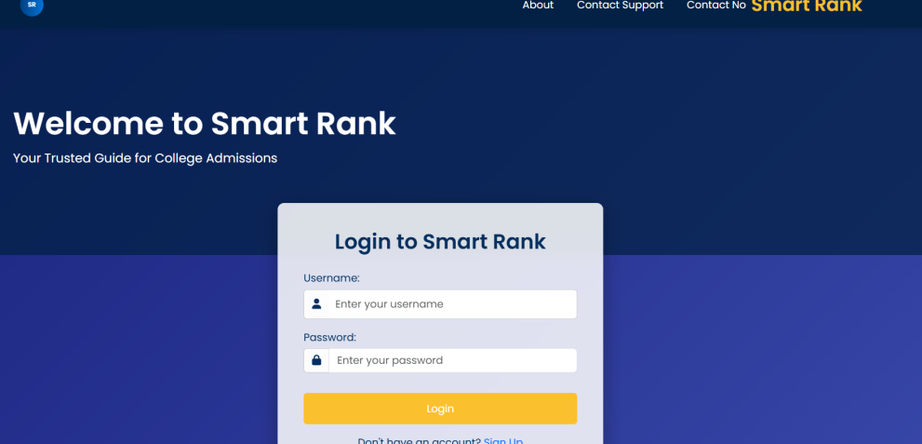
Figure 7.1 : Login page of Smartrank System

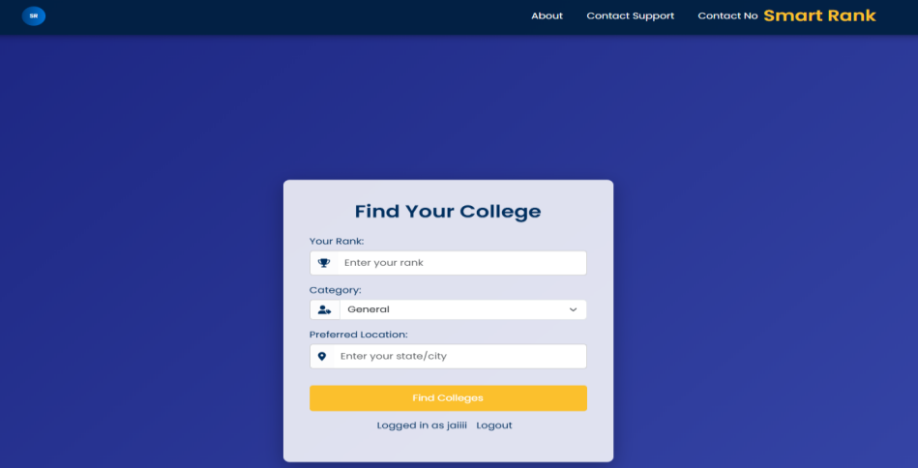
Figure 7.2 : Teacher Dashboard of SmartClass (Interface)

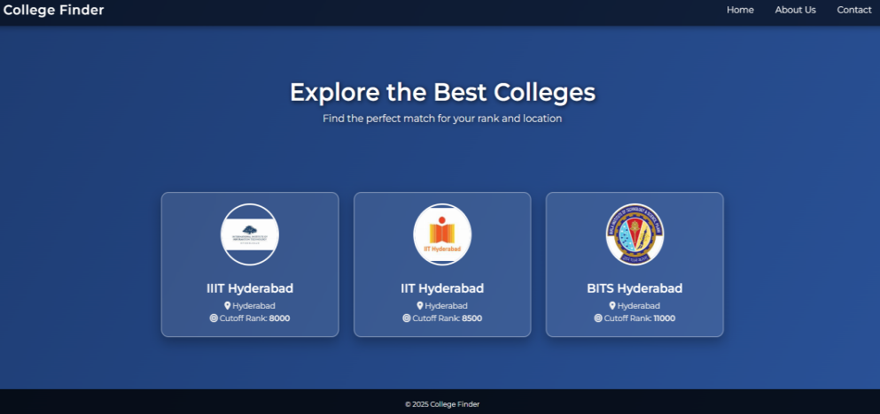
Figure 7.3 : Teacher Dashboard (Manual attendance)

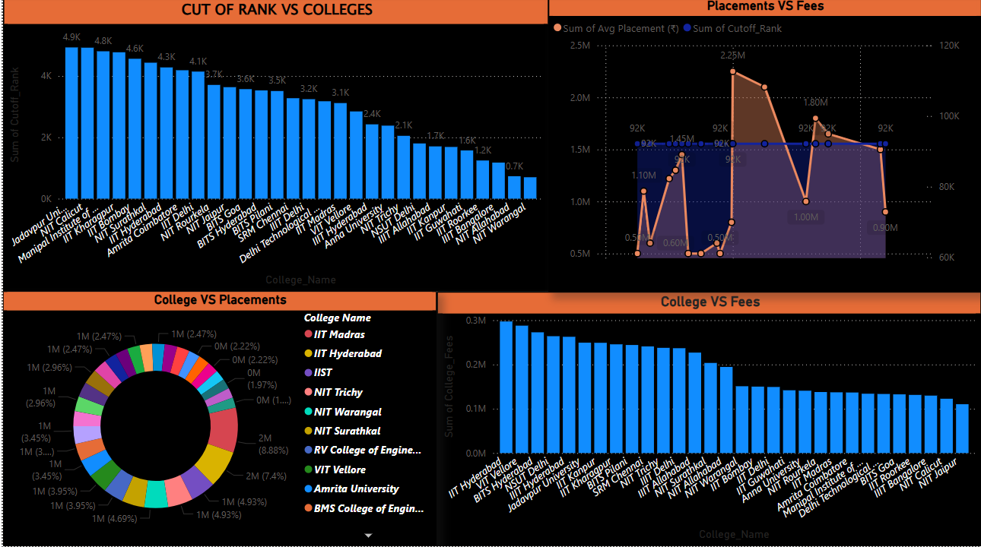

8. TESTING

8.1 Introduction to Testing and Validation
Testing and validation are crucial to ensure that SmartRank performs as expected and delivers accurate, user-relevant results. Through testing, we evaluate whether different functionalities behave correctly under various conditions, while validation confirms that the system aligns with user needs and the core objective of simplifying college selection. These steps help identify bugs, usability gaps, and logical flaws early in development. By systematically comparing expected and actual outcomes, we build confidence that SmartRank is both functional and reliable. The results of this process are summarized below to illustrate how well the system performs under real-world scenarios.

8.2 Testing and Validation Status Overview
The testing outcomes for SmartRank show that the system is currently performing well in its core functionalities. Valid inputs such as a correct exam rank result in appropriate college recommendations, and filtering based on the user’s preferred state works seamlessly. Even error handling for invalid rank entries has been tested and passed successfully, ensuring the application remains user-friendly and robust. The system also allows users to save colleges for later review, which has been verified to work correctly. These successful results indicate that SmartRank's primary features are stable and user-ready, although additional enhancements and optimizations may be introduced in future iterations.

Test Case | Expected Output | Status
Valid Rank | Colleges with cutoff ≥ entered rank | Passed
Invalid Rank | Error message | Passed
Filter by State | Show only colleges from selected state | Passed
Save College | College added to user's saved list | Passed

9.CONCLUSION AND FUTURE SCOPE

9.1 Conclusion
The SmartRank system represents a thoughtful and practical advancement in college admission guidance for engineering aspirants across India. Designed to bring clarity, transparency, and fairness to the college selection process, SmartRank eliminates the guesswork traditionally involved in matching student ranks with suitable institutions. The platform offers a rule-driven prediction model that mirrors real-world cutoffs and admission logic, ensuring that students receive accurate and reliable recommendations tailored to their entrance rank, category, and location preferences. This is especially valuable for students in underserved regions or those without access to expert counseling services, enabling them to make informed decisions with confidence.
At its core, SmartRank combines simplicity with intelligence. Its intuitive user interface allows seamless interaction, requiring students to input only a few essential details to receive filtered and personalized results. The backend logic processes these inputs against historical trends and eligibility rules, ensuring each recommendation aligns with realistic admission possibilities. This automated filtering system not only saves time but also reduces confusion and stress commonly associated with manual college research. The system’s responsiveness and mobile compatibility ensure that students can access it from anywhere, reinforcing its usability and reach.
SmartRank is also designed with scalability and long-term adaptability in mind. Although the current version focuses on engineering admissions, the system is built to support additional streams, states, and entrance examinations through modular expansion. Future updates may include AI-based preference learning, ranking algorithms, or integration with real-time counseling portals, further enhancing its predictive accuracy and value. Overall, SmartRank is a dependable and forward-looking solution that empowers students to navigate the complex admission landscape with ease, transparency, and confidence.

9.2 Future Scope
Looking ahead, the future scope of SmartRank envisions a series of impactful enhancements aimed at transforming the college admission prediction experience into a more intelligent, inclusive, and user-friendly system. One of the most significant expansions would be the inclusion of multi-exam support. By incorporating additional entrance tests such as JEE Advanced, MHT-CET, and other state-level exams, SmartRank can broaden its utility and cater to a wider demographic of aspirants across India. This multi-exam compatibility will allow students from different educational backgrounds and regions to benefit from personalized predictions based on their specific exam performances.
To further assist students in navigating the complexities of college admissions, SmartRank could implement a Natural Language Processing (NLP) based chatbot counseling feature. This intelligent assistant would be capable of answering queries, guiding students through the application process, suggesting institutions, and explaining category-specific criteria—all in real time and conversational language. Such a chatbot would democratize access to counseling services, especially for students in remote or under-resourced areas.
Another transformative feature would be the integration of APIs from official counseling portals. This would enable SmartRank to pull real-time data such as opening and closing ranks, seat allotment updates, and round-wise results directly from authorized sources. By staying in sync with actual admission cycles, the system would provide the most accurate and timely guidance, reducing misinformation and guesswork.
SmartRank’s value could also be significantly enhanced by incorporating placement statistics and alumni reviews for each recommended college. By presenting students with success stories, average package data, and real-world feedback from past graduates, the system would allow for more informed decision-making that goes beyond rank-based cutoffs. This addition would shift SmartRank from a prediction tool to a comprehensive decision-support platform.
The introduction of an AI-based suggestion enhancement layer is another key future enhancement. Leveraging machine learning models, this layer would analyze patterns in user behavior, preferences, and historical admissions to offer smarter and more context-aware college suggestions. Over time, the system would evolve to learn from usage data and adapt its recommendations accordingly, ensuring even more accurate outcomes for future users.
Lastly, a native mobile app version for Android and iOS devices is planned to make SmartRank accessible on the go. This mobile expansion would allow students to interact with the platform conveniently from their smartphones, receive instant alerts, save shortlisted colleges, and revisit prediction results anytime, anywhere. With push notifications and offline capabilities, the mobile app would greatly increase user engagement and convenience.
In summary, SmartRank is on a path to becoming not just a rank predictor, but a comprehensive, AI-augmented college admission assistant. With its vision for multi-exam support, real-time integration, conversational counseling, and mobile accessibility, SmartRank is poised to set a new standard in digital academic guidance. These future enhancements will ensure that the system continues to evolve alongside the dynamic landscape of higher education in India.

10.REFERENCES

- JoSAA. (2025).
Joint Seat Allocation Authority – Official Counseling Portal.
https://josaa.nic.in
- College Pravesh. (2025).
Engineering College Predictor and Cutoff Analysis Platform.
https://collegepravesh.com
- Shiksha. (2025).
Engineering College Predictor Tool.
https://shiksha.com/engineering/college-predictor
- Careers360. (2025).
College Predictor and Admission Guidance Platform.
https://careers360.com
- Flask Documentation. (2025).
Flask – The Python Micro Web Framework.
https://flask.palletsprojects.com
- MySQL Documentation. (2025).
MySQL Developer Reference Guide.
https://dev.mysql.com
- Microsoft Power BI Team. (2025).
Power BI – Business Intelligence and Analytics Platform.
https://powerbi.microsoft.com
- Bootstrap. (2025).
Bootstrap – Responsive Frontend Framework.
https://getbootstrap.com
- Stack Overflow & GitHub Contributors. (2025).
Developer Discussions, Forums, and Open Source Resources.
https://stackoverflow.com and https://github.com

